LAMPIRAN GAMBAR DAN TABEL
- GAMBAR
Gambar 2 QFM Down Grade

Gambar 3 QFM Reject/Scrap

Gambar 4 Diagram Fishbone Defect
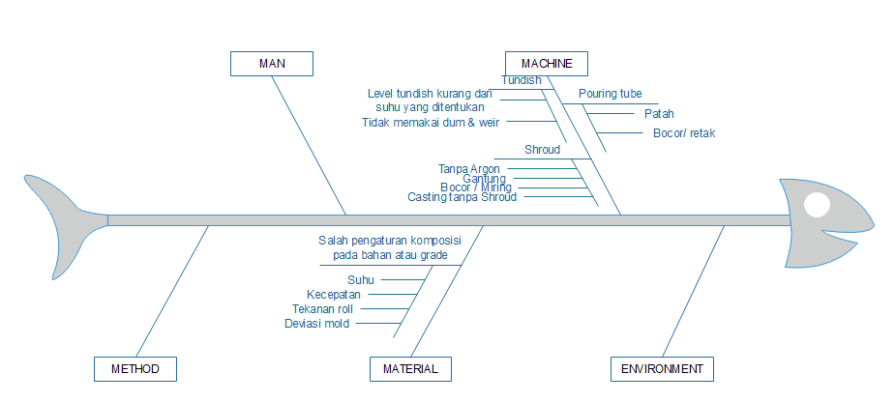

Gambar 5 Diagram Fishbone Over Production
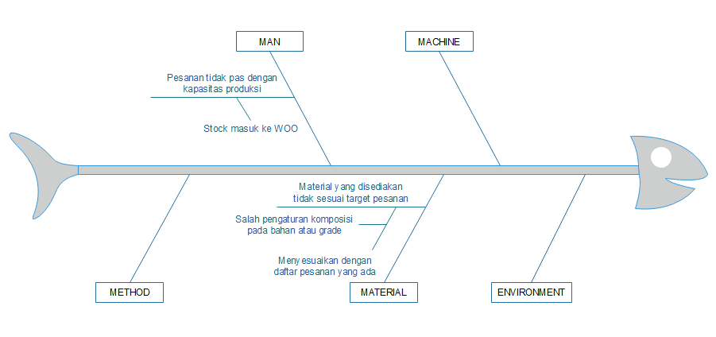

Gambar 6 Diagram Fishbone Waiting
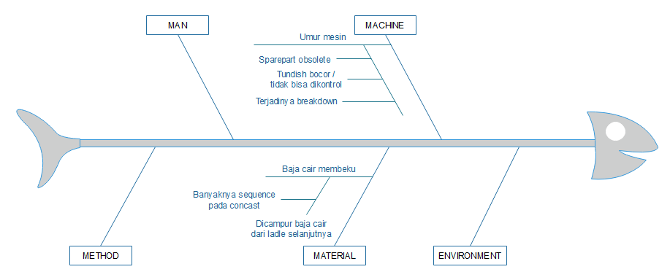

Gambar 7 Diagram Fishbone Unnecessary Motion
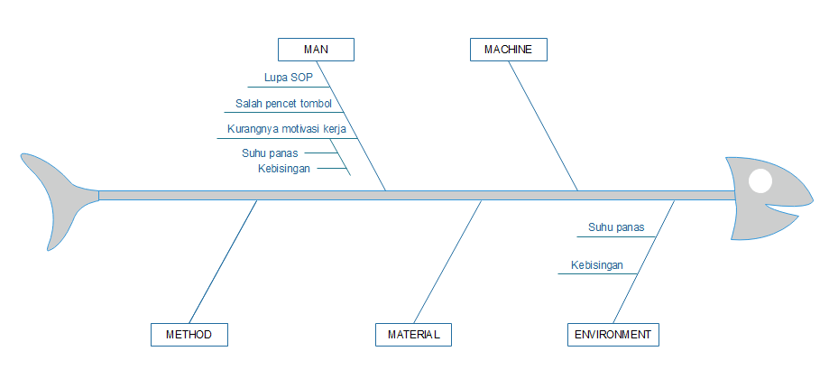

Gambar 1 Current Value Stream Mapping (CVSM)
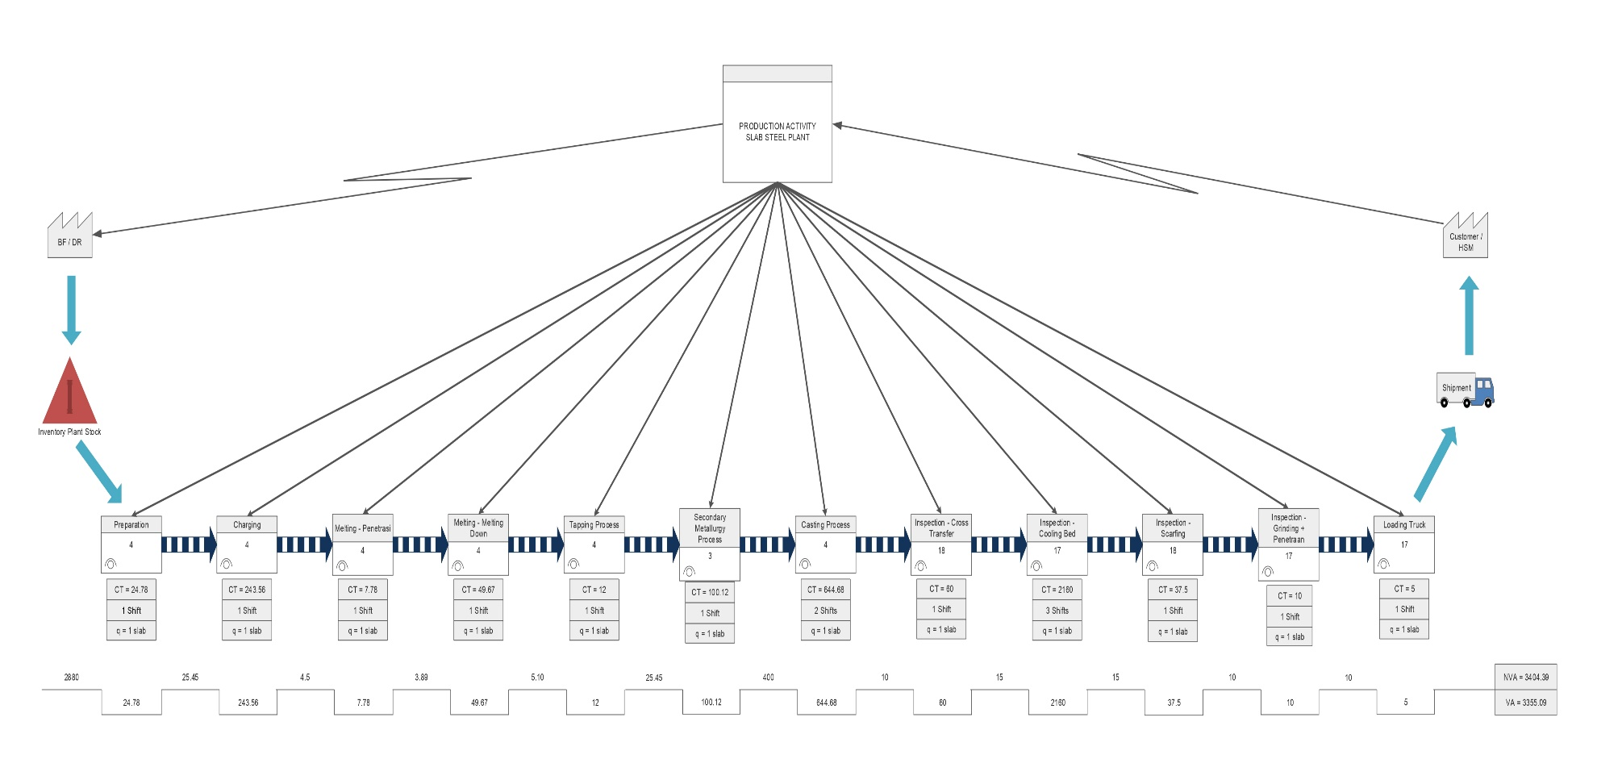

Gambar 8 Future Value Stream Mapping (FVSM)
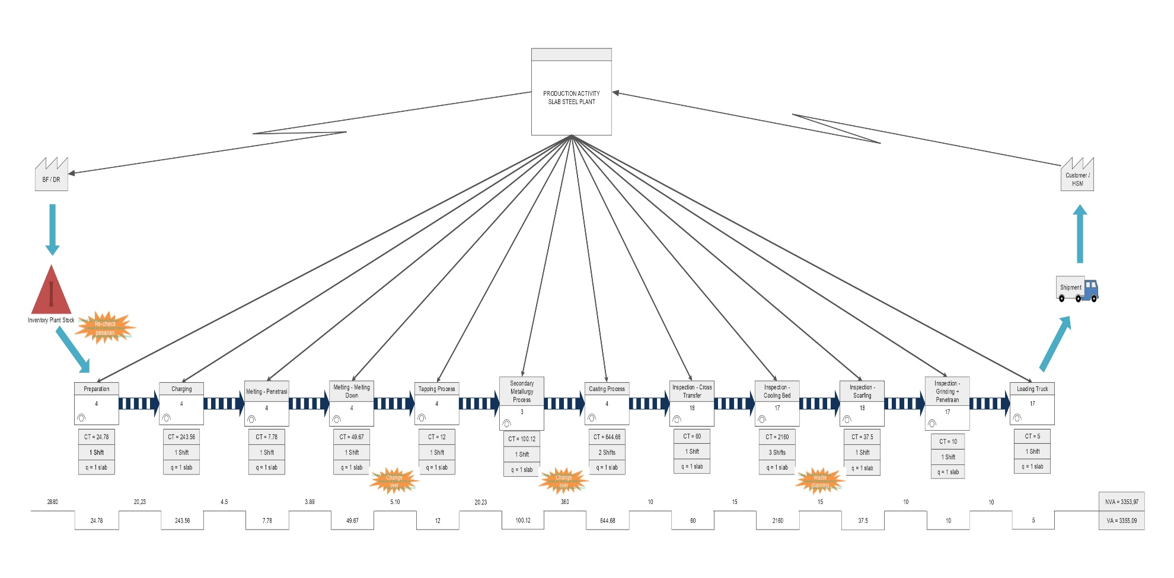

- TABEL
Tabel 1 Perbandingan Biaya Kualitas
Tabel 2 Identifikasi 7 Pemborosan

Tabel 3 5W+1H
Tabel 5 Process Activity Mapping
Tabel 4 Hasil Pemilihan Tools VALSAT

Tabel 6 Penjelasan Process Activity Mapping

Tabel 7 Failure Mode and Effect Analysis

