Mediating Indonesian Islamic Center in the Post-Islamic Era

¹Purnama Hidayaturrahman, ²Holy Rafika Dhona
^{1,2}Department of Communication Science, Universitas Islam Indonesia, Yogyakarta
E-mail: ¹ purnama.pn734@gmail.com, ²holy.rafika@uii.ac.id
+6281393281819

Abstract. Islamic Center have emerged when Muslims in the West had difficulty to build a mosque, a place for Islamic ritual praying. Muslim is a majority in Indonesia and there is no need to adopt the concept of Western Islamic Center. Nevertheless, establishing an Islamic Centers is quite popular among Indonesian Muslims. In this paper, we argue that the construction of the Islamic Center is a practice of post-Islamism in Indonesia where Islam is interpreted in a specific way that juxtaposes religiosity and leisure, the mixture between 'the sacred' and 'the profane'. The formation of this post-Islamic space is the effect of space mediation. This study takes the Mataram Islamic Center on the island of Lombok as a case study. Our main question is how discourse in the mediation of the Islamic Center shapes its construction. This study took several units of analysis from the mediation act of the Mataram Islamic Center; pamphlets, publications on social media and visiting practices by visitors at the Islamic Center. With the critical discourse analysis, we found that there were two prominent discourses namely the Islamic Center as a religious space and the Islamic Center as a tourist space, both of which did not defeat each other

Keywords: communication geography, place, post-Islamic, tourism.

INTRODUCTION
Nowadays, we can find many Islamic center buildings in every region of Indonesia. The first Indonesian Islamic Center was Pusat Dakwah Islam or called by PUSDAI (Pusat Dakwah Islam) located in Bandung, West Java province. The discourse of PUSDAI development was emerged in 1978, precisely during the reign of Governor H. Aang Kunaefi. This idea was then approved on 11 September 1980. It was agreed that the main function of the PUSDAI is an instrument in developing and spreading Islam and Islamic culture in West Java (Kustianingrum, Dwi; Rozi, Awang; Firdaus, Faizal; Mulyanidya, Fiky, 2013) Starting from the establishment of PUSDAI in West Java, many Islamic Center was developed in Indonesia.
Actually, Islamic Center in Indonesia is an adoption from Western societies. In the West, it is a place for Muslims to carry out Islamic activities. It is a substitute for the mosque (masjid) because the mosque was difficult to build. Prof. Syafii Karim wrote that the Islamic Center is a term that comes from Western countries where muslim is a minority, ".. to meet all the needs of Islamic activities they find it difficult to find a place. For this reason, Islamic activities are centered in a forum called the Islamic Center” (Muis, 2010). However, western writer usually did not differ between the mosque and Islamic center, both of two is a same entity (Farrag, 2017)
Indonesian society seems to have its own interpretation toward Islamic Center. That means that the Islamic Center, as a discourse, is understood differently by the Indonesian people then the Western society. ‘NTB Islamic Center’ which was located in Mataram, Lombok Island, Nusa Tenggara Barat is the best example for this. Although Lombok is known as ‘the island of a thousand mosques’ (Pulau Seribu Masjid), and Muslim is become major population, ironically, NTB provincial government still needs to build an Islamic Center. In 2010, the government build the Islamic Center which has an area of 7.6 hectares with the great and majestic Hubbul Wathan Mosque as its main building. It also has ballroom facilities, meeting rooms, and several other VIP rooms.
Furthermore, NTB Islamic Center instead became the 'icon' of Lombok, the island of a thousand mosques. Of the many mosques in the city of Mataram, NTB Islamic Center has the largest and most luxurious mosque. Unlike the mosque, it has not only for religious purposes (such as praying, religious gathering with Ustadz and UIama) but also for 'leisure' such as an art market, procurement of events, as well as a tourist destination that opened to the public, both the local and foreign. (Effendi, 2016)
NTB Islamic Center has been researched by Mustain (2018). From a political perspective, Mustain wrote that the Islamic Center is a symbolic instrument of power from many actors in Lombok. He stated that Tuan Guru Bajang (TGB), as the Governor of NTB, has a significant role in building it as a symbol of Islam. That is, Musta'in's research was based on the belief that the Islamic Center is a symbol of Islam. Research on the Islamic Center with the same tendency was also written by Saprillah Syahrir who connected the Islamic Center Muadz bin Jabal in Kendari with salafism. (Syahrir, 2017).
However, many researches tended to see Islamic Center as site of tourism, not from its religious dimension. For example, there are two research on tourist motivation to going through Masjid Agung Islamic Centre Kabupaten Rokan Hulu (Amalina, 2017) (Wulandari, Ayu; Erianjoni, 2018). Rida Mardia (2017) who researched the Islamic Center of Dato Tiro in Bulukumba city argued that the Islamic Center nowadays is not only a symbol of religion/Islam. Mardia stated that the Islamic Center function has been changed to be a tourist destination or a place for taking a picture/selfie. So the Islamic Center is not only about religious purposes but also leisure since it is a center for all activity for Muslim society
Recognizing this problem, we believed that the Islamic Center in Indonesia is an example of post-Islamism practices. With the definition of the Islamic Center rather than a mosque, the Islamic religious place has flexible meaning, that is, what can and what cannot be done in this place becomes ambiguous or unclear.
NTB Islamic Center, in particular, is a post-Islamic space where there are efforts to showing Islam is not secular, not so much idealistic and also not rigid. This concept popularized by Asef Bayat who stated that 'Post-Islamism' has a characteristic where Islam tended to be pragmatic, realistic and willing to make peace with other realities, while 'Islamism' is a reading about Islam as a complete social, political, economic, and moral system that has answered all human problems (Bayat, Asef; T M, Faiz, 2007, p. 97)
Bayat took Tehran, the capital city of Iran, as an example for a post-Islamic place. Tehran was originally a city that was divided into two; the southern region which is traditional and poor and the northern regions which rich and westernized. Then in 1989, President Rafsanjani appointed Ghulam Husein Karbaschi to neutralize all Tehran's chaos. Karbaschi created many public parks, built a cultural complex in the south, and a connecting road between north and south. Tehran has had a new character and turned into a city that hard to be characterized as 'Islamic city'. Its symbols, toll roads, billboards, malls, shopping centers have become the first signs of the emergence of Post-Islamism in Tehran. According to Karbaschi, Tehran public park is a central park that has a view of the landscape as a door to social security where social class, ethnic differences mingle with a morally safe recreation space (Bayat, Asef; T M, Faiz, 2007, p. 99).
Space/place itself is not essential or permanent. It is formed and constructed by many things. Space according to Lefebvre (1991, p. 33) is a social space that is the accumulation of social practices. Meanwhile, scholars of geography argue that communication/mediation of a space/place greatly influences how space/place is interpreted by a human. (Burgess, J., & Gold, J. R., 1985) (Adams, 2009). Mediation is a communication/media subfield of study related to symbols that represent a space then, now and in the future. This field of study will further explain how space is constructed by the mediation as well as the act of communication (Dhona, 2018, p. 13)

Therefore, this paper aims to see how the mediation of NTB Islamic Center constructs this place as a post-Islamic space. The research questions raised are: 1) How the NTB Islamic Center was constructed in mediation activities? 2) How is the NTB Lombok Islamic Center as a practice of post-Islamism?

METHOD
The data of this research collected by a one-month observation & interviewing several informants such as NTB Islamic Center, the traders around the place and also the tourists. In addition, we collected text data, especially those relating to Islamic Center mediation on social media.
To analyze the data, we use Michel Foucault’s discourse analysis which emphasizes the constellation of power that occurs in the process of production and reproduction of meaning. In this research we follow Dhona (2020) suggestion that Foucaultian discourse analysis is not textual-linguistic analysis.
We define the discourse as all practices that systematically shape or construct the objects discussed by those practices. The object here include actions and events. Dhona (2020, p. 194), quoted Sara Mills, argued that the discourse construct a particular action, so that an action can be understood as an action that is serious action and real. By treating the data as discourse, we interested in subjectification in the discourse of NTB Islamic Center or how the discourse of NTB Islamic Center construct post-Islamic subject.

RESULTS AND DISCUSSION
a. A Brief History of NTB Islamic Center
The development of NTB Islamic Center building officially began in 2009. At that time the Detail Engineer Design (DED) developed by PT. Penta Engineering from Bandung had already finished. Based from the design plan, the Islamic Center will consist of several buildings including, the mosque building, the main minaret of the mosque, the meeting/multipurpose building, the center of Islamic studies, the library and the museum. The first erection was carried out in 2010 with the laying of the first stone carried out by the Tuan Guru Bajang and attended by former regional development minister Helmy Faishal Zaini, Ir. H. Badrul Munir (the deputy governor ), Chairperson of the NTB Provincial DPRD, several leader of NTB government institution, government officials, religious leaders, and community leaders. Since its erection in 2010, the construction of the Islamic Center complex has been carried out gradually and continuously until now.
Many questions raised at the beginning of NTB Islamic Center development, especially about the function of the Islamic Center. Lombok is the island of a thousand mosques where mosques can be found in every village there, so there is no need to build another big mosque. The main question that raised is why the Islamic Center was built next to the previous Central mosque or 'Masjid Raya' namely At-Taqwa Mosque (Najamudin, 2018).
The first building stood in NTB Islamic center area is the Hubbul Wathan Grand Mosque. The inauguration of the use of Hubbul Wathan Mosque was held on Monday, 12 September 2016 by the Governor of NTB at the time, M. Zainul Majdi or Tuan Guru Bajang. It marked by drum beating after the Eid al-Adha prayer 1437 H and the signing of the inscription.
It was claimed by the head management of the Islamic Center as the first Masjid Raya in Mataram, even it is only a successor to the previous Raya mosque, the Attaqwa Mosque. Attaqwa Mosque was planned to be used as a library and museum. This replacement caused a lot of controversies, especially from Jamaah Tabligh community who has made the At-Taqwa Mosque as the center of their activities.
Masjid Raya or the Great Mosque itself is a mosque located in the Capital City of the Province, stipulated by the local Governor based on recommendations from the Head of the Provincial Ministry of Religion office. It imagined as the center of religious activities in a particular province and funded by the Provincial Government (APBD) and Community funds. Hubbul Wathan Mosque becomes Masjid Raya of NTB Province based on the NTB Governor's Decree Number: 451.7-91 of 2017 (Source: a pamphlet of NTB Islamic Center)
According to an interview with the head management of the Islamic Center Management, there will be other buildings in NTB Islamic Center area. One of them is the Education Building which is still being planned. Other buildings to be built are Sharia hotels and parks in collaboration with NTB Syariah banks to support and coordinate various activities at the Provincial level (Jamsuri, S. 2018)
The Syariah hotel is a practice of the discourse of 'halal tourism' in Lombok. On November 9th, 2018, NTB Province was awarded by Republika as a favorite halal tourist destination in the Republika Syariah Award (ASR). NTB has also been awarded Indonesian the best halal destination in 2019 according to Indonesian Muslim Travel Index (IMTI) (Puspita, S; Prodjo Wahyu A. 2019) and also best tourist destinations Halal Honeymoon in the world in 2015. (Junita, N. 2016) Halal Tourism is a kind of Islamic discourse engaged in tourism. It is defined as a system of tourism based on shari'ah rules and Islamic standards. That means that NTB Islamic Center as a religious place is connected to the discourse of tourism/leisure. By this discourse, the practice of recreation/having fun legitimated to carried out in a transcendental place.

b. Mediating and Constructing NTB Islamic Center
The mediation of NTB Islamic Center in Lombok is carried out in various forms of medium. Several media have been analyzed in this subchapter, including pamphlets, websites, Islamic Center accounts on social media and several online articles that contain news about the Islamic Center.

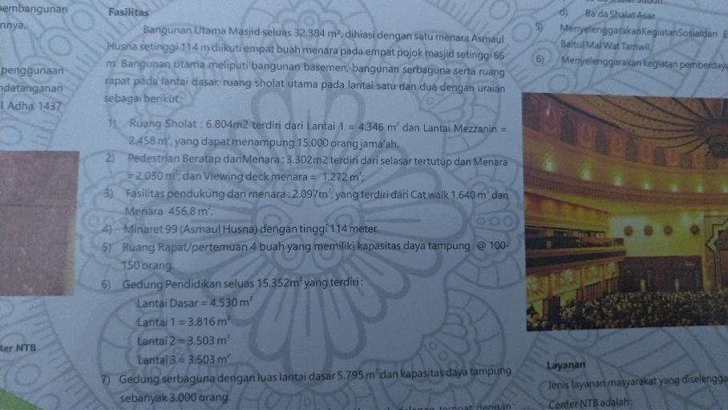

FIGURE 1. Company Profile of NTB Islamic Center

The picture above is one of the pamphlets produced by the management of NTB Islamic Center which aims to provide information related to management, facilities, services, activities and a brief history of the Islamic Center. This pamphlet was made as a Company Profile by the UPT Islamic Center from NTB Provincial Government. The pamphlet is a way for managers to sell facilities and services in the Islamic Center
This pamphlet described the information about services provided by NTB Islamic Center. The mosque as the main building represented as a place of the marriage event. The multipurpose building described as a place that can be rented out for meetings, workshops, seminars, wedding receptions and so on. The pamphlet also represented NTB Islamic Center as a religious tourist destination for school children at all levels. From these representations, this pamphlet positioned NTB Islamic Center not only as a religious space but also a tourist place and even a versatile place that can be used and enjoyed for those who could pay. It is, then, a tourist object/destination and positioned who come pilgrim as a tourist.
Pamphlets, as a communication medium, are usually used to promote something. We often encounter these kinds of pamphlets at tourist destination as a tool for marketing. The existence of this medium and its contents positioned NTB Islamic Center as an inclusive and commercialized space.
In addition to the pamphlet, the NTB Islamic Center also uses a website. The Islamic Center website has been visited 46,531 times since its first posting covering the Khazanah Ramadhan in 2017 and posted on May 25, 2017. The website is very active in posting their activities, especially the activities held on the national level.

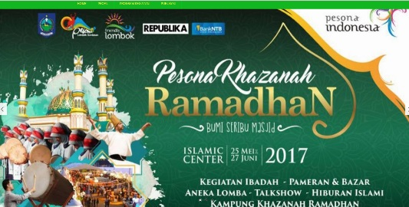

FIGURE 2. The front-page of NTB Islamic Center Website

This site mostly contained from NTB Islamic Center activities, mostly religious activities. It was produced by UPT Islamic Center to provide information daily activities such as the schedule of praying, the schedule of dialog after praying, the Friday praying and also yearly activities like Khazanah Ramadhan, Bazaar, several exibitions, Tabligh Akbar, Idul Fitri and Idul Adha praying and so on. But, the front page of this site shows some familiar logos that identify NTB Islamic Center as a tourist destination. They were logo of Pesona Indonesia and Pesona Lombok Sumbawa.
Pesona Indonesia is Indonesian brand for tourism. This brand was initiated by Indonesian Minister of Tourism, Arief Yahya (Noviyanti, Sri dan Asdhiana, I Made. 2014) In addition to the Pesona Indonesia logo, there is also the Logo of Pesona Lombok Sumbawa, that is an annual event held by the West Nusa Tenggara Tourism Office. This event aimed to attract tourists through several activities held in several tourist destinantions in Lombok and Sumbawa. This event has entered its fifth year in 2018. So, these logos positioned the religious activities contained by the website as the activities in term of tourism.
Other NTB Islamic Center mediations are carried out through social media. The Islamic Center used several social media tools that is popular in Indonesia; Facebook, Instagram and YouTube. The Offical Facebook of NTB Islamic Center doesn't describe much about NTB Islamic Center even though this page has been loved by 8,413 accounts and followed by 9,656 Facebook users since it was first created on May 31, 2017. This account contains a lot of lecture documentation . The information that can be obtained in this account includes lecturers at prayer times, imams, discussion or studies. Most of the content displayed contains lectures filled by Ustadz, scholars, sheikhs, as well as large guests from home and abroad. In contrast to the website which has not been actively posted, so far the Islamic Center facebook account is still actively posting lectures. The last posting was conducted in May 2019 where the content contained Live Prayer activities during the month of Ramadan, Prayer Time and other religious activities.

Instagram is one of the very active media used by Islamic Center administrators in mediating their activities. The activities that posted was include both religious activities to non-religious activities. The first posting was done on May 12, 2017. It was the photo Competition and VLOG competition with prizes of millions of rupiah. It held by collaboratin between NTB Islamic Center with Republika Online. This first post was an invitation from the Islamic Center Manager so that the community could participate in the competition and to introduce the Islamic Center in NTB through Republika Online.

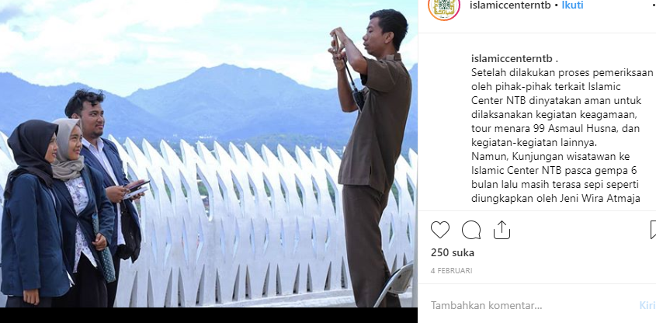

FIGURE 3. Instagram NTB Islamic Center

Figure 3 is one of picture published in Instagram of NTB Islamic Center. It was not a picture of religious activity; it was captured students with UNRAM (University of Mataram) uniform and captioned by a confirmation of NTB Islamic Center management that the Islamic Center was ready and safe to be used again. Although the sentence shows that the Islamic Center is safe for religious activities, tower tours and other activities, but the photo displayed was a photo of a student taking a photo on the minaret, meaning that this medium has legitimated the Islamic Center as a tourism space
In this post, it can be seen that the manager wants to allay travelers' fears of coming to the NTB Islamic Center due to the 2018 earthquake that caused severe damage to the Islamic Center. The post indicated that the NTB Islamic Center was ready to be used again, both as a place of worship, tourism, marriage or as a place for other activities. In the official Instagram account, the content posted tends to be an activity around the Islamic Center mosque where the discourse of tourism space becomes more prominent. Confirming that the Islamic Center is ready to be used again after inspection means inviting worshipers and tourists to coming again to the Islamic Center.
Various kinds of mediation can be found through several official accounts from the Islamic Center of Mataram. Some mediation represented NTB Islamic Center as a tourist destination with the texts shown as on Instagram accounts and also online media, but there are also some texts mediated (YouTube and Facebook accounts) which legitimizes Islamic Center discourse as a place of worship by only posting religious activities.
Mediation constructed NTB Islamic Center as a tourist destination as well as religious place. This means there is a contestation in interpreting NTB Islamic Center. Apart from the contestation, this space could be explained by the Post-Islamists concept as an inclusive, open and morally safe space where the user of the room carries out a safe and happy fun activity, meaning without fear of losing their faith.
As a result, the subject formed in such a space is ambiguous. Some people understand that the NTB Islamic Center is a place of worship. For example, Raden Amir Hamzah who was met during the observation argued that he felt the Islamic Center more as a place of worship. Meanwhile, Muhammad Sofiyuddin, a student at the University of Mataram, believes that the NTB Islamic Center is a tourist spot, ”For me…this place is merely like a tourist destination” (Sofiyudin, M. 2018). Nina Nurwaida Anggita Pradani, a children's book writer from Bima, received information about the Islamic Center through an article she got from the Internet that discussed the Islamic Center as a tourism destination. "The article ... mm the article continued say tourism in Lombok, yes it was about tourism, then the Islamic Center is one of tourist destination " (Pradani, N. 2018)

c. NTB Islamic Center as a site of Post-Islamism practice
Post-Islamism that is meant by Asef Bayat is a project and conditions. The condition of Post-Islamism is about how the social and political conditions where ‘Islamism’ starts to run out of resources. ‘Islamism’ in this sense is a social movement that wants to maximize the application of Islamic law and teachings in all aspects of life. In post-islamic condition, even those who are passionate about Islamism themselves begin to leave Islamism. So, the people involved in the post-Islamism project are not secular, not anti-Islam and not too non-Islamic (Heriyanto, 2015, p. 59). In this sense, Islamism has begun to be abandoned and the community has become part of the Post-Islamism project where it is not secular. The community has begun to enjoy its freedom.
However, according to Bayat, the emergence of Post-Islamism did not rule out the possibility that we could witness the process of Islamization and Post-Islamization going together (Heriyanto, 2015, p. 60). Such is the case in seeing the NTB Islamic Center as a space for Post-Islamism. The Post-Islamism space in this study is seen as a space that is not at all exclusive, not secular and open to other ideologies. The discourse of NTB Islamic Center as a place of religion and tourist attractions is a manifestation of an inclusive space because it brings together transcendent religious activities with "leisure" activities or what we called by ‘tourism’.
Not only that, the Islamic Center opened its gates to the public including for non-Muslim tourists, but with the condition of closing ‘aurat’ (the part of our body that have to be covered under Islamic law). We can see both of islamism and post-islamic tendencies going together at the NTB Islamic Center when tourists are allowed to enter the Islamic Center to travel (post-Islamization) but on the other hand they must obey the prevailing Islamic law, which is closing the aurat (islamism).
In this condition, the Islamic Discourses in tourism such as "Halal Tourism", "Islamic Tourism" legitimize the NTB Islamic Center as a post-Islamic space. Travelers who come to the NTB Islamic Center are free to choose whether he comes as a congregation of the Hubbul Wathan mosque who is obedient to God or a tourist who wants to enjoy the beauty of the building and fulfill his pleasures. However, halal tourism is a practice of Islamism when tourism activities are carried out based on Islamic law. Graburn (2001) wrote that modern tourism is equivalent to religious activities (pilgrimage) carried out by traditional communities, that is, people who are afraid of God.
To put NTB Islamic Center as analogous like Teheran post-Islamic space may be dangerous, as there are many contextual different between NTB and Teheran. But there is one significant condition in which we could rely our argument. In 2016, NTB was marked by BNPT as the red zone of terrorism. This red zone predicate was conveyed by the Head of the Indonesian BNPT Inspector General of Police M Tito Karnavian during a Working Visit to the NTB in last March, 2016. Meanwhile, NTB Police Chief, Drs. Umar Septono confirmed what was conveyed by the Head of the BNPT RI, Inspector General of Police. Tito Karnavian, is quite evident from the many terrorists arrested in Poso, some of whom are from Bima Regency (Arifin Zainal. 2016).

CONCLUSION
Islamic Center in Indonesia is the adoption of Western culture. We argue that the rise of Islamic Center discourse in Indonesia allows a religious place to be multifunctional place, that is post-Islamic place. This study takes the case of the NTB Islamic Center where it was developed into a religious place as well as a place of leisure. Space/place is depended on how it is mediated and this study proves that mediations activities has constructed NTB Islamic Center as Post Islamic spaces.

ACKNOWLEDGEMENT
We would like to thanks the participants of 2nd Annual Conference of Communication, Media and Culture (ACCOMAC) 2019 at UNISBA Bandung, the reviewers and editors who have provided insightful idea, meaning reviews and comments on this paper.

REFERENCES

Arifin Zainal. 2016. NTB Menjadi Zona Merah Penyebaran Faham Radikalisme. RRI.co.id http://rri.co.id/post/berita/261793/nasional/ntb_menjadi_zona_merah_penyebaran_faham_radikalisme.html. Accesed in Mei 2019
Direktorat Penerangan Agama (1976), Petunjuk pelaksanaan (JUKLAK) proyek Islamic centre di seluruh Indonesia oleh Departemen Agama, Direktorat Jenderal Bimbingan Masyarakat (DITJEN BIMAS)
Dhona H. R. (2017), Memikirkan Ulang Media dalam Komunikasi Geografi http://www.remotivi.or.id/kupas/374/Memikirkan-Ulang-Media-dalam-Komunikasi-Geografi (accesed on 20 April 2018)
Dhona, H.R. (2018), KOMUNIKASI GEOGRAFI, Jurnal Komunikasi Vol 13(1)
Dhona, H. R. (2020). Analisis Wacana Foucault dalam Studi Komunikasi [Using Foucauldian Discourse Analysis in Communication Studies]. Journal Communication Spectrum, 9(2), 189-208. http://dx.doi.org/10.36782/jcs.v9i1.2026
Effendi 2016, BERKUNJUNG KE MASJID ISLMAIC CENTER DI MATARAM, https://www.kompasiana.com/tjiptadinataeffendi21may43/57b95d616c7e611a10d3b2fa/berkunjung-ke-masjid-islamic-centre-di-mataram?page=all diakses 3 Mei 2019
Ek, Richard (2006) Media Studies, Geographical Imaginations and Relations Space, Nordicom. Goteborg University, Sweden
Erdiono, Deddy, Imanuddin, Faizah Mastutie, (2017). Islamic Contemporer Cultural Center Di Manado Symbol Kaligrafi Arabesque Sebagai Strategi Desain, Vol 6, No 1, diambil dari https://ejournal.unsrat.ac.id/index.php/daseng/article/view/15639 (16 April 2018)
Graburn, N. (2001) Secular Ritual: A general theory of tourism. In V.L. Smith (Eds.), Hosts and guests revisited. Tourism Issues in the 21st Century. New York: Cognizant Communication Corp.
Halwati, U., (2013), Analisis Foucault Dalam Membedah Wacana Teks Dakwah Di Media Massa, Jurnal Komunikasi Penyiaran Islam, Vol.1(1)
Heryanto, Aril (2015), IDENTITAS DAN KENIKMATAN POLITIK BUDAYA LAYAR INDONESIA, Diterjemahkan oleh Eric Sasono, Jakarta : PT Gramedia
Jaelani, A. (2017), Halal tourism industry in Indonesia: Potential and prospects, Munich Personal RePEc Archiv
Jansson & Falkheimer, (2006). Geographies of Communication, NORDICOM, Goteborg University
Junita, N. 2016. Lombok destinasi wisata halam terbaik untuk bulan madu. Bisnis.com. https://traveling.bisnis.com/read/20160210/224/517670/lombok-destinasi-wisata-halal-terbaik-untuk-bulan-madu- (accesed on May 2019)
Koentjaraningrat, (1983), Metode-Metode Penelitian Masyarakat : Gramedia, Jakarta
Kustianingrum, Dwi; Rozi, Awang; Firdaus, Faizal; Mulyanidya, Fiky, 2013. Laporan Penelitian Kajian Tatanan Massa dan Bentuk Bangunan Pusat Dakwah Islam Bandung Jurusan Teknik Arsitektur Fakultas Teknik Sipil dan Perencanaan Institut Teknologi Nasional Bandung
Lefebvre, Henri (1991), The Production of Space, Diterjemahkan oleh Donald Nicholson-Smith. Cambridge: Basil Blackwell, Inc.
Lexy J. Moleong, (2002), Metodologi Penelitian Kualitatif, Bandung : PT Remaja Rosdakarya, Bandung
Mardia Rida (2017), PERUBAHAN FUNGSI MASJID ISLAMIC CENTER DATO TIRO SEBAGAI DESTINASI WISATA DI KOTA BULUKUMBA, Makassar : Universitas Islam Negeri Alauddin
Muis, Abdul (2010), ISLAMIC CENTER DI KEPANJEN KABUPATEN MALANG (TEMA: REGIONALISME ARSITEKTUR, Malang : Universitas Islam Negeri Maulana Malik Ibrahim
Mustain (2018), Islamic Center dan Peran Kekuasaan dalam Konstruksi Identitas Islam di Lombok, Jurnal Penelitian, Vol. 12(2)
Najamudin (2018), Resolusi Konflik Pembangunan Islamic Center Dan Masjid At-Taqwa Mataram , Komunike, Vol 5(2)
Noviyanti, Sri dan Asdhiana, I Made. 2014. Peluncuran Wonderful Indonesia dan Pesona Indonesia. Kompas.com . https://travel.kompas.com/read/2014/12/24/164500827/Peluncuran.Wonderful.Indonesia.dan.Pesona.Indonesia. Accesed ini Mei 2018
Pamungkas A S, 2016, Produksi Ruang dan Revolusi Kaum Urban Menurut Henri Lefebvre, https://indoprogress.com/2016/01/produksi-ruang-dan-revolusi-kaum-urban-menurut-henri-lefebvre/, di akses 20 Maret 2018
Puspita, S; Prodjo Wahyu A. 2019. Lombok jadi destinasi wisata halal terbaik di Indonesia versi IMTI 2019. Kompas.com. https://travel.kompas.com/read/2019/04/08/190500527/lombok-jadi-destinasi-wisata-halal-terbaik-di-indonesia-versi-imti-2019?page=all accessed on May 2019
Setiawan B. (2019), Lombok Memiliki Wisata Halal Terbaik di Indonesia versi IMTI, https://travel.tempo.co/read/1194060/lombok-memiliki-wisata-halal-terbaik-di-indonesia-versi-imti diakses 14 Mei 2019
Sukmadinata, N.S. (2011), Metode Penelitian Pendidikan. Bandung: Remaja Rosadakarya
Rahman Nasir, 2013, Pemanfaatan Islamic Centre Sebagai Lembaga Pendidikan Islam Non Formal (Studi kasus di Islamic Centre Al-Barokah Purwantoro Wonogiri), Solo : Universitas Muhammadiyah Surakarta
Riduwan. (2004), Metode dan Teknik Menyusun Tesis, Cetakan Pertama. Bandung : Alfabeta
Widodo P. dan Syahputra Ilham (2013), Studi Perancangan Islamic Center Lhokseumawe Melalui Pendekatan Secara Modern Dengan Tetap Mempertahankan Unsur Lokal Konten Dan Spiritualitas Islam, Jurnal Tingkat Sarjana Bidang Seni Rupa, No 1.
Jamsuri S. (12 Novenber 2018). Interview Jamsuri (Hidayaturrahman P, Interviewer)
Pradani N. (15 November 2018). Interview Pradani. (Hidayaturrahman P, Interviewer)
Sofiyuddin, M (15 November 2018) Interview Sofiyuddin. (Hidayaturrahman P, Interviewer)
UPT Islamic Center, (2018), Islamic Center Nusa Tenggara Barat, pamphlet

