APPENDIX

Appendix 1.The Tabulation of Secondary Data (Continued)

No Perushaan Tahun Total Aset
in Billion
Company Size LN (Total Aset)
IO (%) Leverage
(DER) %

Profitability (ROA) (%)

.
Dividend Payout Ratio (%)

Nasional
1 Bank Central 2016 | 676,739 | 13.42504 | 89.00 | 507.50 | 4.00 | 23.90
Asia Tbk. 2017 | 750,320 | 13.52826 | 96.74 | 479.30 | 3.90 | 27.00
2018 | 824,788 | 13.62288 | 96.74 | 454.20 | 4.00 | 32.40
2 Bank Negara 2016 | 603,032 | 13.30973 | 98.24 | 576.10 | 2.70 | 34.89
Indonesia 2017 | 709,330 | 13.47208 | 99.19 | 603.80 | 2.70 | 36.35
(Persero) 2018 | 808,572 | 13.60303 | 98.83 | 628.40 | 2.80 | 25.01
3 Bank Mandiri 2016 | 1,038,706 | 13.85349 | 99.04 | 537.32 | 1.95 | 45.00
(Persero) Tbk. 2017 | 1,124,700 | 13.93303 | 97.79 | 512.94 | 2.72 | 45.00
2018 | 1,202,252 | 13.99971 | 98.91 | 499.08 | 3.17 | 45.00
4 Bank Rakyat 2016 | 1,004,801 | 13.82030 | 98.86 | 569.76 | 3.84 | 40.00
Indonesia 2017 | 1,127,448 | 13.93547 | 99.06 | 559.30 | 3.69 | 40.00
(Persero) 2018 | 1,296,898 | 14.07549 | 98.80 | 588.67 | 3.68 | 45.00
5 Bank 2016 | 91,371 | 11.42268 | 98.23 | 473.90 | 3.10 | 47.00
Tabungan 2017 | 95,489 | 11.46677 | 96.64 | 473.60 | 2.10 | 40.40
Pensiunan 2018 | 101,919 | 11.53193 | 96.17 | 454.00 | 3.10 | 25.44
6 Bank Woori 2016 | 22,630 | 10.02703 | 81.73 | 412.94 | 1.93 | 17.19
Saudara 2017 | 27,086 | 10.20677 | 86.07 | 343.53 | 2.37 | 22.50
Indonesia 2018 | 29,631 | 10.29658 | 88.03 | 352.35 | 2.59 | 18.35
7 Bank 2016 | 174,087 | 12.06731 | 98.43 | 379.51 | 2.50 | 34.99
Danamon 2017 | 178,257 | 12.09098 | 98.70 | 355.06 | 3.10 | 35.00
Indonesia 2018 | 186,762 | 12.13759 | 98.21 | 345.30 | 3.10 | 34.99
8 Bank 2016 | 43,032 | 10.66970 | 90.81 | 496.88 | 2.98 | 63.43
Pembangunan 2017 | 51,518 | 10.84969 | 94.62 | 559.13 | 3.12 | 56.96
Daerah Jawa 2018 | 62,689 | 11.04594 | 95.02 | 639.96 | 2.96 | 54.26
9 Bank Mestika 2016 | 10,587 | 9.26738 | 89.45 | 294.81 | 2.30 | 33.47
Dharma Tbk. 2017 | 11,817 | 9.37729 | 89.46 | 283.37 | 3.19 | 22.71
2018 | 12,093 | 9.40038 | 89.45 | 291.61 | 2.96 | 22.57
10 Bank Rakyat 2016 | 11,377 | 9.33935 | 95.84 | 487.62 | 1.49 | 18.91
Indonesia 2017 | 16,325 | 9.70045 | 95.39 | 424.62 | 1.45 | 37.78
Agroniaga 2018 | 23,313 | 10.05677 | 93.42 | 426.94 | 1.54 | 18.15
11 Bank 2016 | 166,679 | 12.02383 | 99.47 | 765.00 | 1.60 | 20.00

Tbk.

Timur

Appendix 1.The Tabulation of Secondary Data (Continued)

No Perushaan Tahun Total Aset
in Billion
 |  |  |  |  |  | (%)
Maybank 2017 | 173,253 | 12.06251 | 99.38 | 734.00 | 1.48 | 19.74
Indonesia 2018 | 177,533 | 12.08691 | 99.37 | 608.00 | 1.74 | 24.00
12 Bank Bumi 2016 | 7,121 | 8.87080 | 91.26 | 449.19 | 1.52 | 25.08
Arta Tbk. 2017 | 7,014 | 8.85566 | 91.99 | 414.71 | 1.73 | 25.80
2018 | 7,297 | 8.89522 | 91.70 | 388.19 | 1.77 | 26.00
13 Bank Mega 2016 | 70,532 | 11.16382 | 99.33 | 475.02 | 2.36 | 50.00
Tbk. 2017 | 82,297 | 11.31809 | 99.35 | 529.90 | 2.24 | 50.00
2018 | 83,761 | 11.33572 | 99.34 | 507.72 | 2.47 | 40.65
14 PT. Adira 2016 | 27,643 | 10.22713 | 92.50 | 455.39 | 3.70 | 32.90
Dinamika 2017 | 29,492 | 10.29187 | 92.47 | 413.35 | 5.00 | 35.84
Multi Finance 2018 | 31,496 | 10.35762 | 92.47 | 348.15 | 6.00 | 49.96
15 Asuransi 2016 | 1,434 | 7.26822 | 94.38 | 362.00 | 4.00 | 33.85
Ramayana 2017 | 1,418 | 7.25700 | 94.38 | 298.00 | 4.00 | 35.22
Tbk. 2018 | 1,478 | 7.29845 | 94.38 | 264.00 | 5.00 | 41.39
16 PT. Asuransi 2016 | 1,063 | 6.96885 | 81.32 | 290.78 | 3.70 | 33.93
Dayin Mitra 2017 | 1,076 | 6.98101 | 81.32 | 264.45 | 3.70 | 32.89
Tbk. 2018 | 1,061 | 6.96697 | 79.02 | 228.64 | 3.60 | 36.82

Company Size LN (Total Aset)
IO (%) Leverage
(DER) %

Profitability (ROA) (%)
Dividend Payout Ratio

Tbk.

Tbk.

Source: www.idx.com

Appendix 2. The Data Transformation of Inverse (Continued )
No | Perushaan | Tahun | Company Size LN (Total Aset)  in Billion | IO (%) | Leverage (DER) % | Profitabilitas (ROA) (%) | Dividend Payout Ratio (%)
1 | Bank Central Asia Tbk. | 2016 | .07449 | ,01124 | .00197 | .25000 | .04184
 |  | 2017 | .07392 | ,01034 | .00209 | .25641 | .03704
 |  | 2018 | .07341 | ,01034 | .00220 | .25000 | .03086
2 | Bank Negara | 2016 | .07513 | ,01018 | .00174 | .37037 | .02866

Appendix 2. The Data Transformation of Inverse (Continued )

No | Perushaan | Tahun | Company Size LN  (Total Aset) in Billion | IO (%) | Leverage (DER) % | Profitabilitas (ROA) (%) | Dividend Payout Ratio (%)
 | Indonesia (Persero) | 2017 | .07423 | ,01008 | .00166 | .37037 | .02751
 |  | 2018 | .07351 | ,01012 | .00159 | 35714 | .03998
3 | Bank Mandiri (Persero) Tbk. | 2016 | .07218 | ,01010 | .00186 | .51282 | .02222
 |  | 2017 | .07177 | ,01023 | .00195 | .36765 | .02222
 |  | 2018 | .07143 | ,01011 | .00200 | .31546 | .02222
4 | Bank Rakyat Indonesia (Persero) | 2016 | .07236 | ,01012 | .00176 | .26042 | .02500
 |  | 2017 | .07176 | ,01009 | .00179 | .27100 | .02500
 |  | 2018 | .07105 | ,01012 | .00170 | .27174 | .02222
5 | Bank Tabungan Pensiunan Nasional | 2016 | .08755 | ,01018 | .00211 | 32258 | .02128
 |  | 2017 | .08721 | ,01035 | .00211 | .47619 | .02475
 |  | 2018 | .08672 | ,01040 | .00220 | .32258 | .03931
6 | Bank Woori Saudara Indonesia | 2016 | .09973 | ,01224 | .00242 | .51813 | .05817
 |  | 2017 | .09797 | ,01162 | .00291 | .42194 | .04444
 |  | 2018 | .09712 | ,01136 | .00284 | .38610 | .05450
7 | Bank Danamon Indonesia Tbk. | 2016 | .08287 | ,01016 | .00263 | .40000 | .02858
 |  | 2017 | .08271 | ,01013 | .00282 | .32258 | .02857
 |  | 2018 | .08239 | ,01018 | .00290 | .32258 | .02858
8 | Bank Pembangunan Daerah Jawa Timur | 2016 | .09372 | ,01101 | .00201 | .33557 | .01577
 |  | 2017 | .09217 | ,01057 | .00179 | .32051 | .01756
 |  | 2018 | .09053 | ,01052 | .00156 | .33784 | .01843
9 | Bank Mestika | 2016 | .10791 | ,01118 | .00339 | .43478 | .02988

Appendix 2. The Data Transformation of Inverse (Continued )

No Perushaan Tahun
Company Size LN (Total Aset) in Billion

IO (%) Leverage (DER) %

Profitabilitas (ROA) (%)
Dividend Payout Ratio (%)

 | Dharma Tbk. | 2017 | .10664 | ,01118 | .00353 | .31348 | .04403
 |  | 2018 | .10638 | ,01118 | .00343 | .33784 | .04431
10 | Bank Rakyat Indonesia | 2016 | .10707 | ,01043 | .00205 | .67114 | .05288
 | Agroniaga | 2017 | .10309 | ,01048 | .00236 | .68966 | .02647
 |  | 2018 | .09944 | ,01070 | .00234 | .64935 | .05510
11 | Bank Maybank Indonesia Tbk. | 2016 | .08317 | ,01005 | .00131 | .62500 | .05000
 |  | 2017 | .08290 | ,01006 | .00136 | .67568 | .05066
 |  | 2018 | .08273 | ,01006 | .00164 | .57471 | .04167
12 | Bank Bumi Arta Tbk. | 2016 | .11273 | ,01096 | .00223 | .65789 | .03987
 |  | 2017 | .11292 | ,01087 | .00241 | .57803 | .03876
 |  | 2018 | .11242 | ,01091 | .00258 | .56497 | .03846
13 | Bank Mega Tbk. | 2016 | .08958 | ,01007 | .00211 | .42373 | .02000
 |  | 2017 | .08835 | ,01007 | .00189 | .44643 | .02000
 |  | 2018 | .08822 | ,01007 | .00197 | .40486 | .02460
14 | PT. Adira Dinamika Multi | 2016 | .09778 | ,01081 | .00220 | .27027 | .03040
 | Finance Tbk. | 2017 | .09716 | ,01081 | .00242 | .20000 | .02790
 |  | 2018 | .09655 | ,01081 | .00287 | .16667 | .02002
15 | Asuransi Ramayana Tbk. | 2016 | .13759 | ,01060 | .00276 | .25000 | .02954
 |  | 2017 | .13780 | ,01060 | .00336 | .25000 | .02839
 |  | 2018 | .13702 | ,01060 | .00379 | .20000 | .02416

16 | PT. Asuransi Dayin | 2016 | .14350 | ,01230 | .00344 | .27027 | .02947

Appendix 2. The Data Transformation of Inverse (Continued )

No | Perushaan | Tahun | Company Size LN  (Total Aset) in Billion | IO (%) | Leverage (DER) % | Profitabilitas (ROA) (%) | Dividend Payout Ratio (%)
Mitra Tbk. |  | 2017 | .14325 | ,01230 | .00378 | .27027 | .03040
 |  | 2018 | .14353 | ,01266 | .00437 | .27778 | .02716

Appendix 3. The Output of Descriptive Statistics

Descriptive Statistics
 | N | Minimum | Maximum | Mean | Std. Deviation
I_CS | 48 | .07105 | .14353 | .0952838 | .02123000
I_IO | 48 | .01005 | .01266 | .0106566 | .00066771
I_DER | 48 | .00131 | .00437 | .0023787 | .00070324
I_ROA | 48 | .16667 | .68966 | .3863082 | .14252952
I_DPR | 48 | .01577 | .05817 | .0322677 | .01109765
Valid N (listwise) | 48

Appendix 4. The Output of Classical Assumption Test
Normality Test

One-SampleKolmogorov-SmirnovTest

 |  | Unstandardized Residual
N |  | 48
Normal Parameters^{a,b} | Mean | .0000000
 | Std. Deviation | .00857378
Most Extreme Differences | Absolute | .103
 | Positive | .073
 | Negative | -.103
Test Statistic |  | .103
Asymp. Sig. (2-tailed) |  | .200^{c,d}
- Test distribution is Normal.
- Calculated from data.
- Lilliefors Significance Correction.

- This is a lower bound of the true significance.

Multicollinearity Test

Coeficientsª
Model |  | Collinearity Statistics
 |  | Tolerance | VIF
1 | (Constant)
 | INV_IO | .460 | 2.173
 | INV_DER | .275 | 3.631
 | INV_CS | .319 | 3.134
 | INV_ROA | .791 | 1.264
a. Dependent Variable: INV_DPR

Heteroscedasticity Test

Coeficientsª

Model |  | Unstandardized Coefficients |  | Standardized Coefficients | t | Sig.
 |  | B | Std. Error | Beta
1 | (Constant) | -.011 | .013 |  | -.855 | .397
 | INV_IO | 1.447 | 1.464 | .209 | .989 | .328
 | INV_DER | -.975 | 1.797 | -.148 | -.543 | .590
 | INV_CS | .019 | .055 | .087 | .344 | .732
 | INV_ROA | .009 | .005 | .272 | 1.692 | .098
a. Dependent Variable: ABS_RES

Autocorrelation Test

ModelSumary^{b}

Model | R | R Square | Adjusted R Square | Std. Error of  the Estimate | Durbin- Watson
1 | ,635ª | .403 | .348 | .0089637 | 1.463
- Predictors: (Constant), INV_ROA, INV_CS, INV_IO, INV_DER
- Dependent Variable: INV_DPR

Autocorrelation Test (Run Test)

RunsTest
 | Unstandardized Residual
Test Valueª | -.00066
Cases < Test Value | 24
Cases >= Test Value | 24
Total Cases | 48
Number of Runs | 18
Z | -1.897
Asymp. Sig. (2-tailed) | .058
a. Median

Appendix 5. The Output of Multiple Linear Regression Analysis

Coeficientsª
Model |  | Unstandardized Coefficients |  | Standardized Coefficients | t | Sig.
 |  | B | Std.  Error | Beta
1 | (Constant) | -.058 | .026 |  | - 2.249 | .030
 | INV_IO | 7.728 | 2.887 | .465 | 2.677 | .010
 | INV_DER | 2.344 | 3.543 | .149 | .662 | .512
 | INV_CS | -.162 | .109 | -.310 | - 1.486 | .145
 | INV_ROA | .046 | .010 | .593 | 4.479 | .000

a. Dependent Variable: INV_DPR

Appendix 6. The Table of Durbin Watson (α = 5%)
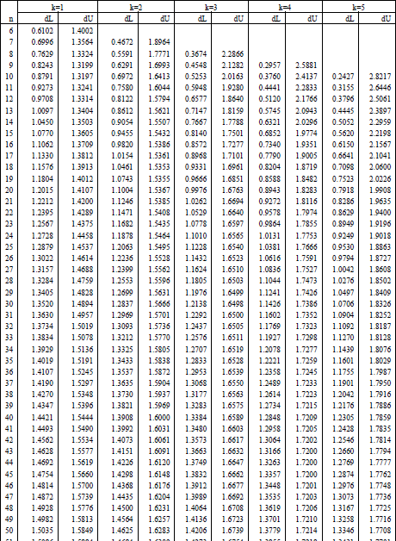

Appendix 7. The Tabel of F Distribution
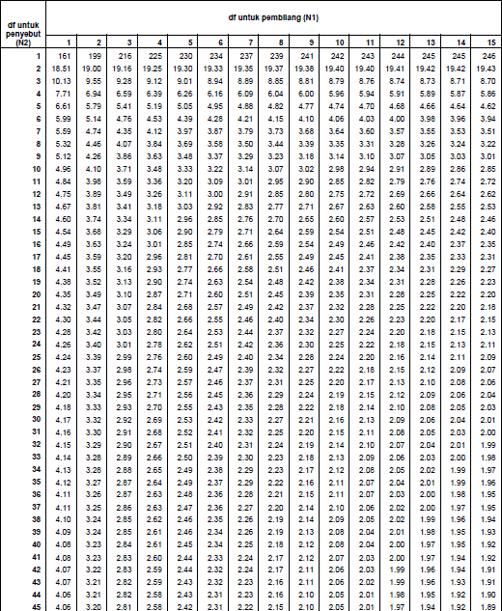

Appendix 8. The Table of T Distribution

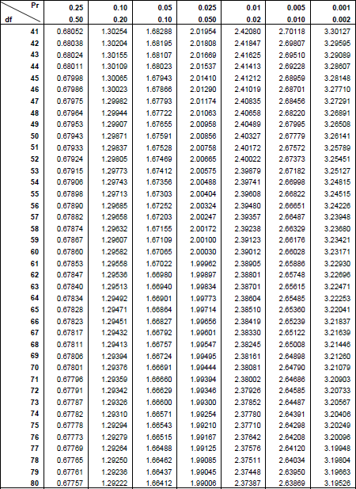

Appendix 9. List of Financial Sector Companies Listed on the
Indonesia (Continued)
No | Kode | Emiten
1 | ABDA | Asuransi Bina Dana Arta Tbk.
2 | ADMF | Adira Dinamika Multi Finance Tbk.
3 | AGRO | Bank Rakyat Indonesia Agroniaga
4 | AGRS | Bank Agris Tbk.
5 | AHAP | Asuransi Harta Aman Pratama Tbk.
6 | AMAG | Asuransi Multi Artha Guna Tbk.
7 | APIC | Pacific Strategic Financial Tbk.
8 | ARTO | Bank Artos Indonesia Tbk.
9 | ASBI | Asuransi Bintang Tbk.
10 | ASDM | Asuransi Dayin Mitra Tbk.
11 | ASJT | Asuransi Jasa Tania Tbk.
12 | ASMI | Asuransi Kresna Mitra Tbk.
13 | ASRM | Asuransi Ramayana Tbk.
14 | BABP | Bank MNC Internasional Tbk.
15 | BACA | Bank Capital Indonesia Tbk.
16 | BBCA | Bank Central Asia Tbk.
17 | BBHI | Bank Harda Internasional Tbk.
18 | BBKP | Bank Bukopin Tbk.
19 | BBLD | Buana Finance Tbk.
20 | BBMD | Bank Mestika Dharma Tbk.
21 | BBNI | Bank Negara Indonesia (Persero)
22 | BBNP | Bank Nusantara Parahyangan Tbk.
23 | BBRI | Bank Rakyat Indonesia (Persero)
24 | BBTN | Bank Tabungan Negara (Persero)
25 | BBYB | Bank Yudha Bhakti Tbk.
26 | BCAP | MNC Kapital Indonesia Tbk.

Appendix 9. List of Financial Sector Companies Listed on the
Indonesia (Continued)
No | Kode | Emiten
27 | BCIC | Bank JTrust Indonesia Tbk.
28 | BDMN | Bank Danamon Indonesia Tbk.
29 | BEKS | Bank Pembangunan Daerah Banten
30 | BFIN | BFI Finance Indonesia Tbk.
31 | BGTG | Bank Ganesha Tbk.
32 | BINA | Bank Ina Perdana Tbk.
33 | BJBR | Bank Pembangunan Daerah Jawa Barat
34 | BJTM | Bank Pembangunan Daerah Jawa Timur
35 | BKSW | Bank QNB Indonesia Tbk.
36 | BMAS | Bank Maspion Indonesia Tbk.
37 | BMRI | Bank Mandiri (Persero) Tbk.
38 | BNBA | Bank Bumi Arta Tbk.
39 | BNGA | Bank CIMB Niaga Tbk.
40 | BNII | Bank Maybank Indonesia Tbk.
41 | BNLI | Bank Permata Tbk.
42 | BPFI | Batavia Prosperindo Finance Tbk.
43 | BPII | Batavia Prosperindo Internasional Tbk.
44 | BRIS | Bank BRIsyariah Tbk.
45 | BSIM | Bank Sinarmas Tbk.
46 | BSWD | Bank Of India Indonesia Tbk.
47 | BTPN | Bank Tabungan Pensiunan Nasional
48 | BVIC | Bank Victoria International Tbk.
49 | CASA | Capital Financial Inddonesia Tbk.
50 | CFIN | Clipan Finance Indonesia Tbk.
51 | DEFI | Danasupra Erapacific Tbk.
52 | DNAR | Bank Dinar Indonesia Tbk.
53 | GSMF | Equity Development Investment

Appendix 9. List of Financial Sector Companies Listed on the
Indonesia (Continued)
No | Kode | Emiten
54 | HDFA | Radana Bhaskara Finance Tbk.
55 | IBFN | Intan Baruprana Finance Tbk.
56 | IMJS | Indomobil Multi Jasa Tbk.
57 | INPC | Bank Artha Graha Internasional
58 | LPGI | Lippo General Insurance Tbk.
59 | LPPS | Lipo Securitas Tbk.
60 | MAYA | Bank Mayapada Internasional Tbk.
61 | MCOR | Bank China Construction Bank
62 | MEGA | Bank Mega Tbk.
63 | MFIN | Mandala Multifinance Tbk.
64 | MREI | Maskapai Reasuransi Indonesia
65 | NISP | Bank OCBC NISP Tbk.
66 | NOBU | Bank Nationalnobu Tbk.
67 | PADI | Minna Padi Investama Sekuritas
68 | PANS | Panin Sehuritas Tbk.
69 | PNBN | Bank Pan Indonesia Tbk
70 | PNBS | Bank Panin Dubai Syariah Tbk.
71 | PNIN | Paninvest Tbk.
72 | PNLF | Panin Financial Tbk.
73 | RELI | Reliance Sekuritas Indonesia Tbk.
74 | SDRA | Bank Woori Saudara Indonesia
75 | SMMA | Sinarmas Multiartha Tbk.
76 | TIFA | Tifa Finance Tbk.
77 | TRIM | Trimegah Sekuritas Indonesia Tbk.
78 | TRUS | Trust Finance Indonesia Tbk.
79 | VICO | Victoria Investama Tbk.
80 | VINS | Victoria Insurance Tbk.

Appendix 9. List of Financial Sector Companies Listed on the
Indonesia (Continued)
No | Kode | Emiten
81 | VRNA | Verena Multi Finance Tbk.
82 | WOMF | Wahana Ottomitra Multiartha Tbk.
83 | YULE | Yulie Sekuritas Indonesia Tbk.
Sources : www.idx.co.id

Appendix 10. Research Sample
No | Kode | Emiten
1 | BBCA | Bank Central Asia Tbk.
2 | BBNI | Bank Negara Indonesia (Persero)
3 | BMRI | Bank Mandiri (Persero) Tbk.
4 | BBRI | Bank Rakyat Indonesia (Persero)
5 | BTPN | Bank Tabungan Pensiunan Nasional
6 | SDRA | Bank Woori Saudara Indonesia
7 | BDMN | Bank Danamon Indonesia Tbk.
8 | BJTM | Bank Pembangunan Daerah Jawa Timur
9 | BBMD | Bank Mestika Dharma Tbk.
10 | AGRO | Bank Rakyat Indonesia Agroniaga
11 | BNII | Bank Maybank Indonesia Tbk.
12 | BNBA | Bank Bumi Arta Tbk.
13 | MEGA | Bank Mega Tbk.
14 | ADMF | PT. Adira Dinamika Multi Finance Tbk.
15 | ASRM | Asuransi Ramayana Tbk.
16 | ASDM | PT. Asuransi Dayin Mitra Tbk.
Sources : www.idx.co.id

