Analysis of consumer preferences for prepaid mobile internet packages in Iran- A Discrete Choice Experiment

Abstract

As a first discrete choice experiment in Iran emerging telecommunication market, this paper studies consumer preferences for prepaid mobile internet packages with a combined software and paper-based interview. To study prepaid mobile data services offered by three mobile network operators in Iran, relevant attributes are identified and their levels are assigned.A two-stage Bayesian D-optimal design procedure is deployed to design choice sets of mobile internet packages from four main attributes. The utility structure and customers’ willingness-to-pay for mobile internet packages are analyzed. The results indicate that even with a considerable price reduction, consumers avoid prepaying for data plans with commitment periods longer than six months and high traffic volume. Traffic volume and brand attributes are recognized as the two most influential factors on consumers’ behavior. Simulating the market demonstrates the competition between mobile internet operators in Iran market. The statistics express a significant effect of consumers’ current mobile operator on their preferences for the brand attribute.

Keywords: Discrete choice experiment, Willingness to pay (WTP), Conjoint analysis, Mobile internet.

JEL Classification: D01 L96.

1. Introduction
Mobile internet is increasingly being recognized as one of the most widely welcomed services in meeting people’s communication needs (Shih et al., 2018) and has surpassed other mobile communication services like voice and SMS. Different telecommunication companies compete locally and globally to increase their market share, optimize their revenue and manage customers churn by offering a wide range of mobile internet plans and packages. Competing in this market applies high fixed costs to telecommunication service providers. In such a growing and competitive industry, utilizing effective marketing research methods is a target for service providers to measure consumers’ purchase behavior, analyze firm-level brand equity and design packages that outperform substitute services.
There are different methods like ordered logit regression models (Luu, 2019) to measure consumer preferences. However, conjoint analysis, particularly discrete choice experiment (DCE), is one of the most popular market research techniques that can be used in a telecommunication market to satisfy the mentioned objectives. It is employed to measure consumers’ preferences between products and services consisting of several attributes that are characterized by their levels. The importance of attributes can also be ranked according to their influence on consumers’ behavior. In a DCE questionnaire, respondents face different scenarios of possible products or services and are requested to opt one of the alternatives in each choice situation.
From a macro perspective, utilization of conjoint analysis to discover consumers’ preferences for mobile internet can help companies, market leaders, and lawmakers to design effective strategies that optimize the GDP, penetration rate of mobile internet, and social welfare. Louviere et al. (2010) state that DCEs are not a form of conjoint analysis. However, mostly in the literature, both DCE and choice-based conjoint analysis (CBC) are used alternatively, and DCE is considered as a particular form of conjoint analysis. The purpose of this paper is to study Iranian consumers’ preferences for prepaid mobile internet packages by employing a discrete choice experiment.
Iran with a population of nearly 80 million people, is the second-largest country in the Middle East (Pourmokhtar et al., 2018). In recent years, Iranians quickly adopt using the internet as the primary tool to facilitate their daily activities. Some examples are employing social media, teleworking, reading, and shopping online. Moreover, by implementing the e-government project in Iran, citizens and businesses are increasingly relying on the internet for doing their daily routines. All these transformations have increased the demand for internet data services. By providing internet in almost all situations and places, mobile internet services are responding to a significant proportion of Iranians’ internet demand.
The ITU ICT Development Index (IDI) is a unique benchmark of the level of ICT development in countries across the world. The International Telecommunication Union (ITU) in a report named “Measuring the Information Society” publishes IDI annually. Iran’s 2017 IDI value is 5.58, 1.32 points above the average for developing countries, and 0.57 points above the world average. IDI ranks of Iran are 81 among 176 counties, and 37 among 130 developing countries. Iran is the second most dynamic country by 0.54 points IDI value improvement between 2016 and 2017. Comparing Iran with Iceland, the first 2017 IDI ranked country, reveals a significant difference between the sub-indexes of active mobile broadband subscriptions per 100 inhabitants. Iran’s 33.77 Active mobile-broadband subscriptions per 100 inhabitants is 70.22 less than Iceland’s 103.99 Active mobile-broadband subscriptions per 100 inhabitants. Furthermore, the percentage of individuals using the internet in Iran is only 53.23, 45.01 percent lower than Iceland, which results in Iran’s 3.54 low IDI use sub-index. This significant difference between the IDI index and IDI use sub-index demonstrates that a potential market for mobile internet exists in Iran. Table 1 shows that total active mobile subscribers in Iran grow year-on-year from 1997, reaching 87,245,262 active mobile subscribers until the fourth quarter of 2017.

Table 1
Total active mobile subscribers in Iran
Date | Mar-97 | Mar-02 | Mar-07 | Mar-12 | Mar-13 | Mar-14 | Mar-15 | Mar-16 | Mar-16 | Dec-17
Population of active subscribers | 59,967 | 2,087,353 | 15,385,289 | 55,426,281 | 59,402,896 | 63,831,568 | 70,920,183 | 75,914,506 | 82,986,304 | 87,245,262

Three mobile network operators, MCI, MTN Irancell, and Rightel, offer consumers two types of services, prepaid and postpaid plans. Table 2 compares the total active population of prepaid and postpaid subscribers. Prepaid plans with 80% share are more popular than postpaid plans. Due to its high popularity, this study focuses on prepaid plans. Before launching MTN Irancell in 2006 and entrance of Rightel to the mobile telecommunication market in 2010, MCI, which was the monopoly power in Iran mobile telecommunication market from 1994, had been offering only prepaid plans. As a result, MCI has the lowest prepaid customer share from its total active customers in comparison with two other operators. According to the pie chart in Fig. 1, Rightel has the lowest market share in the prepaid plan market. MTN, with its 47 percent share is competing closely with the governmental operator, MCI.
Table 2
The proportion of prepaid subscribers to total Active subscribers
Brand | Total Active subscribers | Active prepaid subscribers | The proportion of prepaid subscribers to total Active subscribers
MCI | 51,770,767 | 34,792,112 | 67.2%
MTN | 32,986,356 | 32,656,491 | 99.0%
Rightel | 2,478,829 | 2,429,254 | 98.0%
Total | 87,235,952 | 69,877,857 | 80.1%
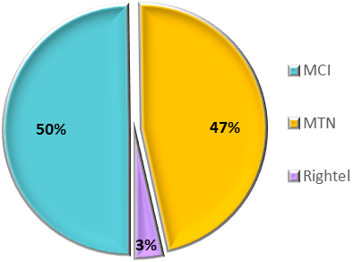
Fig. 1. Active prepaid subscriber

There is a vast literature on conjoint analysis and discrete choice experiment field. Thurstone (1927) introduced the psychological aspect of DCE to measure psychological values and qualitative comparative judgments. Bradley and Terry (1952) studied a two-by-two factorial experiment. Louviere and Woodworth (1983) developed a design method for multiple-choice alternatives. Following these articles, several developments have been done in the discrete choice experiment field.
Examples of utilization of conjoint analysis, as one of the most popular market research methods, can be found in a broad array of disciplines. Strauss et al. (2018) applied it in healthcare. Paci et al. (2018) conducted a study in the food industry. Kim et al. (2018) analyzed the tourism industry using conjoint analysis. In addition to other economic and marketing methods, Conjoint analysis methods and DCEs have been applied in the telecommunication industry extensively ( Koh & Lee, 2010; Kwak & Yoo, 2012; Confraria et al., 2017; Sobolewski & Kopczewski, 2017). However, few studies investigate consumers’ preferences for Internet services using conjoint analysis. Madden and Simpson (1997) investigate the demand for residential broadband services through a discrete choice experiment and analyze the influences of socioeconomic elements on the consumption of the Internet by surveying Australian households. Ahn et al. (2006) employed a conjoint analysis to study consumer preferences for wireless data communication services, including wireless LAN and mobile Internet services by interviewing 500 respondents in South Korea. Rosston et al. (2010) investigated consumers' willingness to pay (WTP) regarding eight factors influencing consumers’ preferences for broadband Internet services. They estimated a random utility model using discrete choice analysis. Kwak and Yoo (2012) represented the first study focusing on the consumers’ choices behavior for 4G technology in South Korea. They evaluated WTP for attributes of the 4G technology by applying a choice experiment. Srinuan et al. (2012) conducted a discrete choice model in Thailand to determine the factors influencing consumers’ choice behavior for mobile internet services. They also recognized inelasticity in demand by cause of a noncompetitive market. Choi and Han (2015) studied the attributes affecting Korean consumers’ preferences for mobile data services. Nakamura (2015) deployed a conjoint analysis to explore substitutability between mobile internet access services and fixed broadband access services in Japan. Dagli and Jenkins (2016) demonstrated consumers’ willingness to pay for enhancements in mobile services. They have focused on 4G upgrades and roaming services in North Cyprus.
The results obtained from previous studies could not be generalized to Iranian consumers, because their choice behavior may be different due to the various market and demographic characteristics. Moreover, we defined and analyzed different attributes and levels, which can determine current prepaid internet packages in Iran. To the best of the authors’ knowledge, this paper is the first that uses discrete choice analysis to measure consumers’ preferences for prepaid mobile internet packages in Iran. This paper represents an empirical analysis of the main determinants affecting consumers’ behavior in Iran’s mobile data market.
The remainder of this paper is organized as follows. Section 2 contains the study methodologies. Section 3 represents a detailed description of selected attributes, their levels, and survey design. Section 4 presents the results of the analysis. A simulation study that is drawn from the data is also demonstrated in section 4. Also, the respondents are clustered according to their current operator. Recommendations and policy implications are also discussed. Finally, the study is concluded in section 5.

2. Research Method
This paper employs a discrete choice analysis to discover preferences regarding prepaid mobile data services. In a DCE, a respondent opts the service that maximizes her satisfaction. Random utility framework, which was pioneered by McFadden (1974), is used to study consumer behavior. In a random utility framework, a scale called utility measures the consumer’s level of satisfaction for a service.
The theory of discrete choice and random utility are based on characteristics demand theory (Lancaster, 1966). In this theory, It is assumed that the consumer's preferences are measured from the attributes of a service, instead of the service as an integrated unit. The utility parameters can be calculated with the multinomial logit model developed by McFadden (1974).
Assuming that the respondent i is supposed to select the alternative perceived as yielding the highest utility among J mobile internet services in each of t scenarios, the person’s utility when choosing alternative j in choice set t can be written as:
(1)
Consumer i chooses service j in comparison with k other alternatives, in the event of U_{ijt}>U_{ikt} for any j≠k. During the consumer buying process, an individual compares the utility of each and purchase the service with the maximum utility. The probability of purchasing internet package j by individual i, namely the probability of U_{ijt}>U_{ikt} for all j≠k , is expressed by:
) for all (2)
Rearranging terms yields:
for all (3)
Considering a typical assumption that the distribution of random disturbance is independent and identical extreme value, the choice probability of alternative j by person i from the choice set can be expressed by:
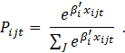 (4)
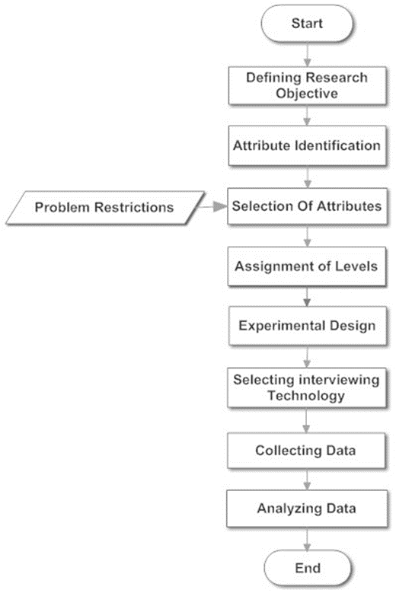
By adoption from Bridges et al. (2011), the steps of the study are arranged in Fig. 2.
Fig. 2. Steps of the study
3. Research design
3.1. Mobile Internet attributes and their levels
One of the critical steps of designing a good DCE is identifying and selecting relevant attributes and assigning their appropriate levels based on the purpose of the study (Hensher et al., 2005). By studying Iran mobile broadband market, several attributes for internet bundles including validity interval, volume, price, brand, free off-peak volume offering, speed, purchasing options can be identified. The more attributes to define a service in a conjoint study, the more complex questionnaires are essential. Consequently, Respondents may utilize simplifying strategies to handle the complexity of questions (Green & Srinivasan, 1978). Eight attributes maximum are advised for a full profile study (Wittink & Cattin, 1989). However, a more conservative approach by (Schwabe et al., 2003), recommends four attributes maximum in a choice experiment. In order to decrease the risk of employing the simplifying strategies by respondents, the attributes are limited to four main ones. The attributes that are required to define any internet bundle are validity interval, traffic volume, price, and brand. Attributes and levels are carefully determined based on the discussions with telecommunication experts and recognizing the most influential attributes on the sale volume and consumers’ choice. After recognizing the attributes, their levels should be assigned. When defining the attribute levels, two guidelines are considered, limiting the number of levels to five to obtain more precise part-worth (Orme, 2010) and equilibrating the number of levels of all attributes to improve the comparability of attribute importance (Wittink et al., 1990). Five levels assigned all except Brand attribute. Due to Iran’s tripoly telecommunication market, the brand attribute was defined by three levels.
In order to detect the current attribute levels offered in the market, all the mobile internet packages offered by three operators were categorized in separated and combined pivot tables according to each attribute. A hierarchical approach was adopted to define the levels of validity interval, volume and price attributes. 10 detected levels of the validity interval were reduced to five that were detected in packages with a higher market share. These five levels are identical between the packages of all operators. In the next step, we recognized 15 levels of volume attribute for each level of the validity attribute. Five levels with the highest sale volume with the objective of covering the broadest possible range of volume levels were selected. In a final step, five levels are assigned to price attribute. Considering USD to characterize the price levels could limit the market simulation study. Alternatively, the price attribute is characterized by USD per gigabyte. We should mention that the prices were converted to the Iranian currency in questionnaires. Table 3 presents the attributes and their selected levels.

Table 3
Attributes and levels
Attribute | Levels | Definition
validity period | 1 Day  7 days  30 Days  180 Days  360 Days | validity period after which the package expires even if the subscriber fails to exhaust the entire purchased data volume
Traffic Volume | 0.2 Gigabyte  1 Gigabyte  3 Gigabyte  12 Gigabyte  24 Gigabyte | Maximum traffic volume which a customer is allowed to use for a fixed prepaid cost, The bundle should be renewed after exhausting the entire data volume available even if the validity period is not expired
Price | 2.125 USD/Gigabyte  1.75 USD/Gigabyte  1.375 USD/Gigabyte  1 USD/Gigabyte  0.625 USD/Gigabyte | Price per gigabyte defines the total fixed prepaid package price by being multiplied to package traffic volume
Brand | MTN  MCI  Rightel | Brands of mobile telecommunication operators in Iran’s triopoly market

3.2. Conjoint experimental design
Once attributes and levels are selected, they must be combined to form hypothetical choice situations. The possible mobile internet services are shown to respondents to select a favorable one. In this study, a two-stage Bayesian D-optimal design was applied to construct a partial profile choice experiment (Kessels, Jones, & Goos, 2011). By maximizing the DB-criterion introduced first by Kessels, Jones, Goos, et al. (2011), the two-stage approach allows for the creation of DB-optimal partial profile design. In this process, the prior distribution of expected parameter values is assumed. At the first stage, the constant attributes in each choice set are determined. At the second stage, the levels of the non-constant attributes are determined. We designed a pilot survey to use the results as prior parameters necessary to design the final survey. We deployed the SAS-based software, JMP, to design the experiment.
Johnson and Orme (1996) studied surveys containing up to 20 choice sets. They concluded that respondents provide high-quality data at a much faster rate in the last stages of choice surveys. Their findings support the practice of requesting respondents to perform many choice questions. Relying on their study, we designed 60 scenarios and blocked them into three sets of twenty. In each Task, a respondent was presented with five alternatives characterizing the mobile internet bundles and the choice of not selecting any bundle.
The survey was conducted during the 19th international exhibition of telecommunications, information technology & innovative CIT solutions at Tehran in 2018. Customers of all three telecommunications operators who had good knowledge about the mobile telecommunication market and mostly up to 50 years old were attended in the exhibition. Therefore, we could obtain meaningful results from their answers. Prior to starting the survey, the respondents were informed that gifts would appreciate them. This action persuaded them to overcome the burden of questions.
Simple customized software for doing a discrete choice survey was developed and installed on the tablets. In the introductory page of the software, we presented the respondents with instructions and examples to help them to participate in the study. After answering each task, the next task was available automatically. The software could record the answering time for each question and the time spent on the introductory page, which could be a useful statistic for furthered analysis. We implemented a hybrid data collection method including both paper-based and software-based surveys to interview the respondents. Some university students were available to guide the respondents during the interview voluntarily. After filtering the unreliable and incomplete questionnaires, 196 questionnaires were analyzed in this study. During the survey, we asked the participants to illustrate the information about their current mobile operator, sex and marital status.

4. Empirical analysis
4.1. Estimation
Descriptive statistics from conducting a multinomial logit model are shown in Table 4. Table 4 describes the part-worth, standard error, lower and upper limit of each level of the attributes. The marginal utility values sum to zero for each attribute. The last level of each attribute is adjusted according to the part-worth of other levels. Fig. 3 is the graph description of the part-worth in Table 4.
Table 5 reports the consumers’ estimated WTP changes, the standard deviation that was calculated by an alpha method, upper and lower limits by 95 percent confidence interval. The Rightel, 24 GB volume, one-day validity interval and 0.625 USD per gigabyte levels were considered as a baseline for measuring WTP changes. For better illustration, the column labeled “New WTP” presents new WTP by adding 0.625 USD to the measured WTP. Consumers’ WTP is expressed in USD per gigabyte.

Table 4
Part-worth of attribute levels
Term | Estimate | Std Error | Lower 95% | Upper 95%
Traffic Volume[0.2GB] | -0.0510 | 0.0389 | -0.1277 | 0.0248
Traffic Volume[1GB] | 0.5401 | 0.0332 | 0.4749 | 0.6049
Traffic Volume[3GB] | 0.2118 | 0.0374 | 0.1382 | 0.2845
Traffic Volume[12GB] | -0.1672 | 0.0396 | -0.2456 | -0.0903
Price[2.125 USD/Gigabyte] | -0.2783 | 0.0434 | -0.3640 | -0.1939
Price[1.75 USD/Gigabyte] | -0.2294 | 0.0397 | -0.3079 | -0.1523
Price[1.375 USD/Gigabyte] | 0.0240 | 0.0360 | -0.0470 | 0.0939
Price[1 USD] | 0.1500 | 0.0366 | 0.0778 | 0.2213
Validity[1d] | -0.4298 | 0.0506 | -0.5293 | -0.3309
Validity[7d] | 0.0893 | 0.0338 | 0.0227 | 0.1553
Validity[30d] | 0.1342 | 0.0389 | 0.0575 | 0.2099
Validity[180d] | 0.1523 | 0.0420 | 0.0694 | 0.2339
Brand[Rightel] | -0.1892 | 0.0282 | -0.2447 | -0.1343
Brand[MTN] | 0.3115 | 0.0250 | 0.2625 | 0.3604
No Choice Indicator | 0.2026 | 0.0426 | 0.1184 | 0.2854
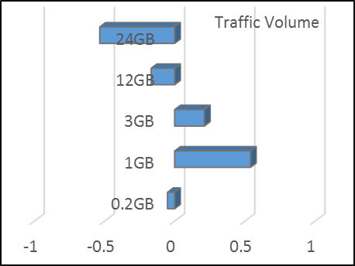
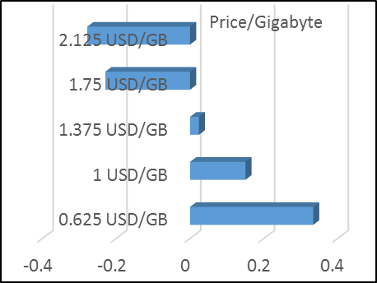
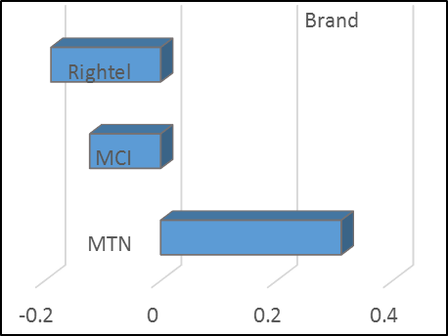
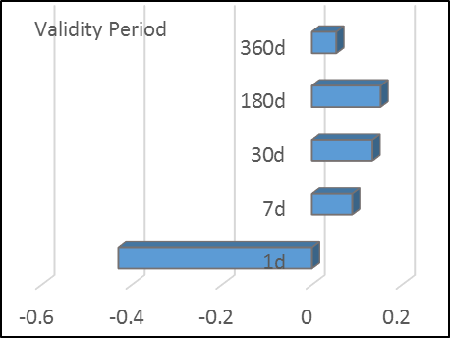
Fig. 3. Part-worth of attribute levels

Table 5
Estimation of willingness to pay
Factor | Feature Setting | WTP Change | Std Error | Lower 95% | Upper 95% | New WTP
Traffic Volume | 0.2GB | 1.12 | 0.16 | 0.82 | 1.43 | 1.75
Traffic Volume | 1GB | 2.48 | 0.21 | 2.06 | 2.90 | 3.10
Traffic Volume | 3GB | 1.72 | 0.17 | 1.39 | 2.05 | 2.35
Traffic Volume | 12GB | 0.85 | 0.14 | 0.57 | 1.13 | 1.48
Traffic Volume | 24GB | 0.00 | 0.14 | -0.28 | 0.28 | 0.63
Validity | 1d | 0.00 | 0.14 | -0.28 | 0.28 | 0.63
Validity | 7d | 1.19 | 0.12 | 0.95 | 1.43 | 1.82
Validity | 30d | 1.30 | 0.13 | 1.06 | 1.55 | 1.93
Validity | 180d | 1.35 | 0.13 | 1.10 | 1.61 | 1.98
Validity | 365 | 1.13 | 0.13 | 0.86 | 1.39 | 1.75
Brand | Rightel | 0.00 | 0.13 | -0.26 | 0.26 | 0.63
Brand | MTN | 1.17 | 0.12 | 0.93 | 1.40 | 1.79
Brand | MCI | 0.16 | 0.09 | -0.02 | 0.34 | 0.78

The coefficients of the price attribute in Table 4 admits that the reduction in price will raise consumers’ utility. By expanding the validity interval to 180 days, the utility continues to improve. However, shifting from 180 days to 365 days validity results in a significant decrease in utility. The information indicates that consumers were not willing to accept a one-year subscription period due to their price sensitivity and risk considerations. The WTP changes resulted from different validity intervals demonstrate the same conclusion as Table 4. Rephrasing it in term of WTP, as an example, a discount of 0.18 USD per gigabyte is required to tempt a consumer subscribing a bundle with a one-year commitment period instead of purchasing a bundle with one-month expiration interval. Increasing the validity interval from one day to seven days results in a significant 1.19 USD per gigabyte WTP increase. Consumers are willing to pay 0.11 USD per gigabyte more to extend the validity period of their package from seven days to 30 days. The operators can charge consumers only 0.05 USD per gigabyte more for offering six times more validity interval than a 30 days validity interval.
According to Table 4, a rise in the size of traffic volume does not necessarily result in an increase in consumers’ utility value. The more the volume of an internet bundle, the more the consumers should prepay for the bundle. So even packages with long validity periods and competitive prices cannot compete with a 1 GB bundle with medium validity. Based on Table 5, considering the 0.2 GB traffic volume as the baseline, consumers are willing to pay 1.36 USD more per GB to purchase a 1 GB bundle. To persuade consumers to shift from a 1 GB to a 3 GB data plan, a 0.76 USD per gigabyte price reduction, and to a 12 GB bundle, a 1.63 USD per GB price reduction is needed. Consumers are willing to pay 0.85 USD per GB less to shift from a 12 GB package to a 24 GB package with the same volume and brand. Therefore, optimized pricing strategies should be applied to encourage consumers to shift to long-term and high-volume packages.
The results indicate that while the ascendant brand in the market is MTN, MCI and Rightel are in the next positions. The considerable dominance of MTN over other brands is reasonable in packages with volume under one gigabyte. However, for long-term and high-volume bundles, this WTP and part-worth difference cannot be applied in pricing decisions. Thus, we recommend an interaction study to rank the brands more precisely.
The P-value and LogWorth values defined as -log10(p-value) in Table 6 verifies that the effects of all four selected attributes are statistically significant and all of the attributes affect the respondents’ utility.
Table 6
P-values and LogWorth values
Source | LogWorth |  | P-Value
Traffic Volume | 73.503 |  | <.001
Brand | 33.236 |  | <.001
Price | 21.134 |  | <.001
Validity | 17.751 | 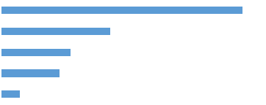 | <.001
No Choice Indicator | 5.589 |  | <.001

LogWorth values in Table 6 and the range of variation between the upper and lower limits of attributes’ utility demonstrate that traffic volume is the most influential attribute in Iranian consumers’ choice behavior. The Brand attribute is perceived to be the second important attribute. Price and validity factors are in the third and fourth priority when choosing mobile internet bundles. However, it should be noted that the excellence of traffic volume attribute from the attribute’s importance perspective, might be the result of its more extensive range of levels. This problem can be examined in further studies.
4.2. Choice simulation
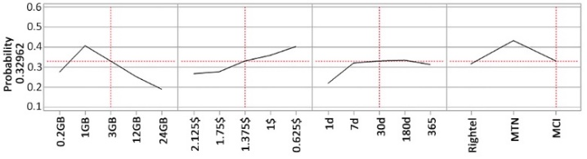
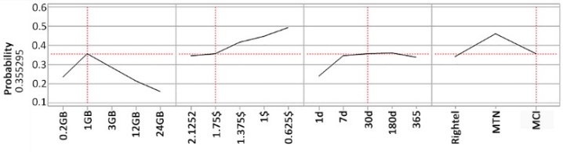
Decision-makers to experiment pricing and product development decisions in a competitive environment can deploy marketplace simulation. The simulator reflects the probability that consumers choose each alternative. Sum of the probability of choosing packages or none of the alternatives by an individual in each choice situation equals one. We used choice data to estimate the probability of choosing each package. In Fig. 4 simulates a choice occasion consisting of two product profiles. In this scenario, it is supposed that in a 30 days validity interval, MCI is offering a 1 GB service for 1.75 USD per GB. MCI is analyzing how to encourage its customers to shift to a 3 GB bundle. Fig. 4 and Fig. 5 demonstrate that a 0.375 USD per GB price decrease cannot satisfy the MCI objective. A 0.75 USD per gigabyte price decrease is required to tempt consumers to buy a 3 GB service rather than a 1 GB bundle with a 30 days validity interval.
Fig. 4. Choice probability comparison of a 1 GB, MCI, 30 days validity at 1.75 USD per GB with a 3 GB, MCI, 30 days validity at 1.75 USD per GB.
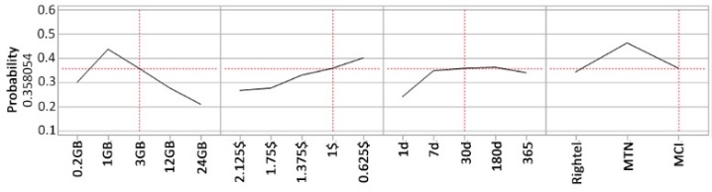
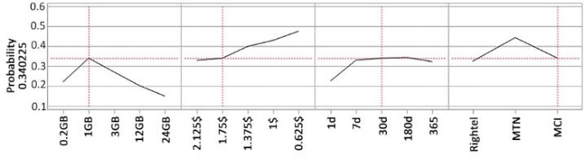
Fig. 5. Choice probability comparison of a 1 GB, MCI, 30 days validity at 1.75 USD per GB with a 3 GB, MCI, 30 days validity at 1 USD per GB.
In Table 7, the same services in Fig. 5 beside two other hypothetical services from other operators are analyzed in a competitive environment. Table 7 reveals that although respondents prefer the new 3 GB MCI service in comparison with a Rightel service with the same specifications and the MCI 1 GB data plan, consumers would rather choosing the MTN 3 GB package at 0.75 USD more per GB. This comparison can be made about a broader range of service profiles to study the products in a competitive environment. Moreover, the market reaction can be studied before introducing new services.
Table 7
Simulation of four packages in a competitive market
Brand | Validity | Traffic Volume | Price | Probabilities
MCI | 30 days | 1 GB | 1.75 USD | 0.199
MTN | 30 days | 3 GB | 1.75 USD | 0.22
Rightel | 30 days | 3 GB | 1 USD | 0.196
MCI | 30 days | 3 GB | 1 USD | 0.209
No Choice |  |  |  | 0.176

4.3. Cluster analysis
One of the useful analyses of choice data is segmenting the market into clusters based on their characteristics and homogeneous preferences. In this section, the interaction between respondents’ demographic characteristics and attributes of services is studied. Respondents are asked about their demographic characteristics, including their current mobile operator, sex and marital status during the experiment. The analysis reveals that only the respondent’s current network operator has a statistically significant effect on describing her preference for the brand attribute. Each of the respondents belongs to one of the seven groups that are defined in Table 8 according to their network operators. Table 9 demonstrate that respondents’ group influences their choice behavior about brand factor. Table 10 and Fig. 6 presents the interaction between brand and respondent operator group.
Table8
Respondent Groups, according to the mobile operators of their current SIM cards.
Respondent Group | Respondents’ current SIM card operators
1 | MNT
2 | MCI
3 | Rightel
4 | MNT, MCI
5 | MCI, Rightel
6 | MNT, Rightel
7 | MNT, MCI, Rightel

Table 9
P-values and LogWorth values for respondent Group and Brand interaction
Source | LogWorth | 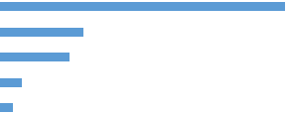 | P-Value
Traffic Volume | 72.87 |  | 0
Price | 21.269 |  | 0
Validity | 17.727 |  | 0
Respondent Group *Brand | 5.535 |  | 0
Brand | 3.252 |  | 0.00056

Table 10
Interaction between respondent Group and Brand
Operator Group | 1 | 2 | 3 | 4 | 5 | 6 | 7
Estimate
Rightel | -0.119 | -0.408 | 0.37 | -0.22 | -0.169 | -0.059 | -0.334
MTN | 0.246 | 0.252 | 0.279 | 0.489 | -0.158 | 0.092 | 0.341
MCI | -0.127 | 0.156 | -0.649 | -0.269 | 0.327 | -0.033 | -0.007

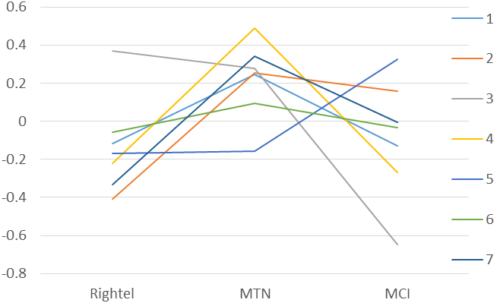
Fig. 6. Interaction between brand and respondents group

Results from Table 10 and Fig. 6 demonstrate that consumers in groups one and three, who are subscribing only one operator, perceive the brand of their current operator as the most favorable. Group 2, MCI consumers, prefer MTN to their current brand, but they are not ready to incur the switching cost. Groups 4 to 6 who are subscribing two different operators at the same time are willing to choose one of their current subscribers as the most preferred option. While it is typical in Iran to use dual subscriber identity module (SIM) smartphones, it can be inferred that when choosing a mobile internet subscriber, respondents prefer the operator of the SIM card that is assigned for using mobile internet. The choice data about respondents belonging to group 7, who have the experience of using all three operators at the same time, indicate the same behavior as when not considering the clusters. The results are relevant and validate the findings. The simulation study indicates that in such an environment, by adopting price discrimination policies between subscribers of different network operators, churn management, and marketing strategies of a firm can be optimized.
4.4. Discussion
Iran is the second most dynamic country by 0.54 points IDI value improvement between 2016 and 2017. Iran’s mobile internet and voice traffic follow the global trend reported in the “Ericsson mobility report 2018”. While mobile data traffic was noticeably boosted, voice traffic and text messaging have not experienced a significant rise during recent years. According to Iran’s Deputy Ministry of communications in Oct 2017, subscribers’ income from SMS and voice traffic has decreased during recent years, and mobile internet packages are considered a significant source of revenue. Consequently, Iran’s mobile telecommunication operators are spending most of their marketing budget and energy on the competitive mobile internet market. These facts demonstrate that a potential market for mobile internet exists in Iran. In this case, Discovering consumer preferences regarding the firm services is clearly beneficial since without it the market outcome is outright market failure. Due to the greater popularity and market share of prepaid plans in Iran and other developing countries, the present article focuses on studying prepaid mobile internet packages. This paper examines both theorical contributions and preactical inplications.
A considerable body of literature has studied the domain of telecommunication economics, marketing and specifically consumer preferences for internet services. Along with other economic and marketing techniques, conjoint analysis methodologies and DCE have also been deployed in the telecommunication industry and studying data services extensively. Nevertheless, previous studies could not be extended to Iranian consumers, because of differences in market and demographic characteristics. On the other hand, according to the authors knowledge, no study exists which deployed discrete choice analysis to measure consumers’ utilities for prepaid mobile internet services.
According to demand theory, the utility for mobile internet service is a function of estimated utility parameters of its attributes. The attributes are carefully determined based on guidelines in the literature, market study and expert judjment. Moreover, by calculating the The P-value and LogWorth values, the effects of all four selected attributes are statistically verified. Theses attributes can also be deployed by practitionairs to explore consumer behavior regarding prepaid mobile internet service in other countries. LogWorth values and the range of variation between the upper and lower limits of attributes’ utility summarise that traffic volume is the most important attribute in affecting Iranian consumers’ choice behavior. The Brand attribute is perceived to be the second influential attribute. Price and validity factors influence the customers’ preferences with lower priority.
We demonstrate how telecommunication companies and industries in Iran and other emerging markets can deploy conjoint analysis as a proved efficient method for analyzing their local and global target markets. Market players can deploy the result of this study to take specific actions. From a revenue and churn management perspective, we conclude that improving service characteristics like volume and validity interval is not always the best strategy to maximize the consumers’ welfare. The results reveal that consumers' risk perceptions and average consumption affect their decisions. Therefore, consumers are not willing to prepay for long commitment periods and high volume packages. Consequently, even with considerable price discounts, operators cannot be successful in increasing the sale of packages with long-term validity periods.
Generally, network operators offer two kinds of SIM cards in Iran, prepaid SIM card with negligible or zero fixed cost and postpaid SIM card that is offered with a fixed cost and guarantees the post-payment of the bill. In order to prevent non-payments, network operators do not offer postpaid plans to prepaid SIM card owners. One risk-free strategy that can be studied to encourage consumers with prepaid SIM cards to purchase services with high validity periods is designing an installment plan. For instance, the network operator can offer its subscribers to prepay around 60% of the total price when purchasing and around 40% after consuming half of the volume or in the middle of the commitment period.
Practitionairs can analyse pricing and product development decisions in a competitive environment by utilizing marketplace simulation. The simulator demonstrates the probability that consumers choose each alternative. The findings from simulation suggest that the brand position has a significant effect on setting the pricing and marketing strategies. Without considering the brand position in pricing, the strategies can cuase the firm significant loose or reduction in profit.
Another notable result is about the preferences of respondents in different segments, who are clustered based on their current mobile operators. It can be inferred that considerable discounts and incentives are essential to persuade MTN customers to shift to other operators. On the other hand, MCI is in a vulnerable situation and may experience churn in its customers if not spending to promote its brand equity. The operators, especially MCI and Rightel should analyze different cooperative scenarios and optimize their packages to maximize their revenue and control the churning of their customers. The brand study indicates that MTN has a superior position in the market. Therefore, to survive in the market, other operators should improve their competitive advantages like improving data transmission speed, expanding the coverage area, offering new payment terms and modern services.
For policymaker, the results reveal that consumers hesitate to purchase high volume bundles because of their high expenses, and this limits the internet consumption rate. New policies like reducing the tax for mobile internet service providers and applying discounts on customs duties for telecommunication devices, investing in the development of infrastructure, and implementing new technologies can lead to fixed costs cutting and, therefore, a price reduction of internet services. According to cluster analysis, the policymaker can set different rules for each operator to prevent a monopoly market and to keep firms in competition besides the objective of increasing consumers’ satisfaction. They can also direct consumers’ interests, especially in less developed areas, to essential social and scientific training programs. The policymaker can achieve this objective by putting obligations or tax exemption for operators in exchange for putting incentives, gift packages or discounts on internet expended on training programs and videos.

5. Conclusions
In this study, we designed a DCE to study consumers’ preferences for mobile internet packages in Iran. Four attributes, including traffic volume, validity period, brand and price are selected to define alternatives in choice sets. The statistics indicate that all the attributes influence the consumers’ choices behavior. Based on the results, the traffic volume is the most critical attribute for customers. The estimations reveal that consumers avoid subscribing packages with a validity period longer than six months because of their risk considerations and avoiding higher prepaid expenses. To motivate consumers to buy long-term and high-volume bundles, designing a price optimization model with the objective of increasing the revenue and sale of target packages is recommended. The comparison of the utility values over consumers showed that their current network operator influenced their preferences about brand attribute. As our knowledge, this study is the first practical DCE in Iran telecommunication industry. Furthermore, we could not find any paper that employs DCE to analyze mobile internet packages by focusing on prepaid Plans. Nevertheless, our study has limitations that further studies can cover them. Interaction analysis between volume and validity interval attributes in a broader sample can help decision-makers to study the market more precisely and implement strategies that are more effective.

References
Ahn, J., Lee, J., Lee, J. D., & Kim, T. Y. (2006). An analysis of consumer preferences among wireless LAN and mobile internet services. ETRI Journal, 28(2), 205-215.
Bradley, R. A., & Terry, M. E. (1952). Rank analysis of incomplete block designs: I. The method of paired comparisons. Biometrika, 39(3/4), 324-345.
Bridges, J. F., Hauber, A. B., Marshall, D., Lloyd, A., Prosser, L. A., Regier, D. A., . . . Mauskopf, J. (2011). Conjoint analysis applications in health—a checklist: a report of the ISPOR Good Research Practices for Conjoint Analysis Task Force. Value in health, 14(4), 403-413.
Choi, S.-S., & Han, S.-S. (2015). A Study on Determinants of ConsumersChoice of Mobile Data Service. The Journal of Korean Institute of Communications and Information Sciences, 40(1), 115-123.
Confraria, J., Ribeiro, T., & Vasconcelos, H. (2017). Analysis of consumer preferences for mobile telecom plans using a discrete choice experiment. Telecommunications Policy, 41(3), 157-169.
Dagli, O., & Jenkins, G. P. (2016). Consumer preferences for improvements in mobile telecommunication services. Telematics and Informatics, 33(1), 205-216.
Green, P. E., & Srinivasan, V. (1978). Conjoint analysis in consumer research: issues and outlook. Journal of consumer research, 5(2), 103-123.
Hensher, D. A., Rose, J. M., & Greene, W. H. (2005). Applied choice analysis: a primer: Cambridge University Press.
Johnson, R. M., & Orme, B. K. (1996). How many questions should you ask in choice-based conjoint studies. Paper presented at the Art Forum, Beaver Creek.
Kessels, R., Jones, B., & Goos, P. (2011). Bayesian optimal designs for discrete choice experiments with partial profiles. Journal of Choice Modelling, 4(3), 52-74.
Kessels, R., Jones, B., Goos, P., & Vandebroek, M. (2011). The usefulness of Bayesian optimal designs for discrete choice experiments. Applied Stochastic Models in Business and Industry, 27(3), 173-188.
Kim, S., Chung, J. Y., Petrick, J., & Park, J. W. (2018). Determination of preferred performing arts tourism products using conjoint analysis. Journal of Vacation Marketing, 24(1), 44-61.
Koh, D., & Lee, J. (2010). Analysis of Consumers' Choices and Time‐Consumption Behaviors for Various Broadcasting and Telecommunication Convergence Services. ETRI journal, 32(2), 302-311.
Kwak, S.-Y., & Yoo, S.-H. (2012). Ex-ante evaluation of the consumers' preference for the 4th generation mobile communications service. Technological Forecasting and Social Change, 79(7), 1312-1318.
Lancaster, K. J. (1966). A new approach to consumer theory. Journal of political economy, 74(2), 132-157.
Louviere, J. J., Flynn, T. N., & Carson, R. T. (2010). Discrete choice experiments are not conjoint analysis. Journal of Choice Modelling, 3(3), 57-72.
Louviere, J. J., & Woodworth, G. (1983). Design and analysis of simulated consumer choice or allocation experiments: an approach based on aggregate data. Journal of marketing research, 20(4), 350-367.
Luu, D. T. (2019). Willingness to pay and actual purchase decision for organic agriculture products in Vietnam. Economic Journal of Emerging Markets, 11(2), 123.
Madden, G., & Simpson, M. (1997). Residential broadband subscription demand: an econometric analysis of Australian choice experiment data. Applied Economics, 29(8), 1073-1078.
McFadden, D. (1974). Conditional Logit Analysis of Qualitative Choice Behaviour”. In Frontiers in Econometrics, ed. P. Zarembka.(New York: Academic Press).
Nakamura, A. (2015). Mobile and fixed broadband access services substitution in Japan considering new broadband features. Telecommunications Policy, 39(2), 140-154.
Orme, B. K. (2010). Getting started with conjoint analysis: strategies for product design and pricing research: Research Publishers.
Paci, F., Danza, A., Del Nobile, M., & Conte, A. (2018). Consumer acceptance and willingness to pay for a fresh fish-burger: A choice experiment. Journal of Cleaner Production, 172, 3128-3137.
Pourmokhtar, E., Moghaddasi, R., Nejad, A. M., & Hosseini, S. S. (2018). Meat demand model in Iran: a restricted source-differentiated almost ideal demand system approach. Economic Journal of Emerging Markets, 10(2), 194-204.
Rosston, G. L., Savage, S. J., & Waldman, D. M. (2010). Household demand for broadband Internet in 2010. The BE Journal of Economic Analysis & Policy, 10(1).
Schwabe, R., Grasshoff, U., Großmann, H., & Holling, H. (2003). Optimal 2K paired comparison designs for partial profiles. Paper presented at the PROBASTAT2002, Proceedings of the Fourth International Conference on Mathematical Statistics, Smolenice 2002, Tatra Mountains Mathematical Publications.
Shih, P.-H., Yang, K.-C., & Yang, C. (2018). The link between state-of-mind and individuals’ willingness to adopt and continue using smartphones. Kybernetes, 47(3), 539-558.
Sobolewski, M., & Kopczewski, T. (2017). Estimating demand for fixed-line telecommunication bundles. Telecommunications Policy, 41(4), 227-241.
Srinuan, C., Srinuan, P., & Bohlin, E. (2012). An analysis of mobile Internet access in Thailand: Implications for bridging the digital divide. Telematics and Informatics, 29(3), 254-262.
Strauss, M., George, G. L., & Rhodes, B. D. (2018). Determining preferences related to HIV counselling and testing services among high school learners in KwaZulu-Natal: A discrete choice experiment. AIDS and Behavior, 22(1), 64-76.
Thurstone, L. L. (1927). A law of comparative judgment. Psychological review, 34(4), 273.
Wittink, D. R., & Cattin, P. (1989). Commercial use of conjoint analysis: An update. The Journal of Marketing, 91-96.
Wittink, D. R., Krishnamurthi, L., & Reibstein, D. J. (1990). The effect of differences in the number of attribute levels on conjoint results. Marketing Letters, 1(2), 113-123.

