AUTHOR DECLARATION
(FORM 1)

We who are undersigned bellow:
No | Name | Address / email / phone number
1 | Hanny Setyowati | Borobudur Natural Industry/ hannytan18@gmail.com  /+6281931976118
2 | Wahyuning Setyani | Sanata Dharma University/ wahyuningsetyani@usd.ac.id/ +628122554811

Hereby declare that the reviewed script of our article/ titled:

FORMULATION OF CHEWABLE LOZENGES OF SOM JAWA (Talinum Paniculatum (Jacq.) Gaertn) LEAVES EXTRACT APPLIED AS ANTISCORBUT Candida Albicans

has not been published in the previous national journals or international journals. We declare that the script is a genuine scientific work that we truly conducted and can be scientifically accounted. This declaration has been made without coercion from other parties. If there are any deception, omission or misconduct in this statement, We are willing to accept any consequences according to UII regulation.

1st Author  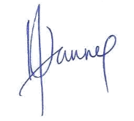  (Hanny Setyowati) | 2nd Author  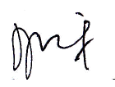  (Wahyuning Setyani)

