AUTHOR DECLARATION
(FORM 1)

I who is undersigned bellow:
No | Name | Address / email / phone number
1 | Handy Darmawan, M.D. | Jayeng Kusuma Street, No. 320, Ketanon, Kedungwaru, Tulungagung Regency, Indonesia (66229) / handy.darmawan92@gmail.com / +62895876825787
2
3
4
5

Hereby declare that the reviewed script of my article/ titled:

An Unusual Cause of Eyeball Rupture: A Case Report

Has not been published in the previous national journals or international journals. I declare that the script is a genuine scientific work that I truly conducted and can be scientifically accounted. This declaration has been made without coercion from other parties. If there are any deception, omission or misconduct in this statement, I am willing to accept any consequences according to UII regulation.

1st Author  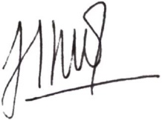  (Handy Darmawan, M.D.) | 2nd Author  (………………………….) | 3rd Author  (……………………………..)

