STATEMENT LETTER

Name : Farhah Kamilah
Institution : Universitas Muhammadiyah Yogyakarta
Institution Address : Jl. Brawijaya, Geblagan, Tamantirto, Kec. Kasihan, Bantul, Daerah Istimewa Yogyakarta
E-mail : farhahkamilah28@gmail.com
Mobile Phone : 0895360088122
Article Title : Sexual Experiences of Girls Engaged in Child Marriage: A Scoping Review

- Author and co-author has sufficiently participated in the writing of this article so the article can be accountable to the public.
- All of the authors have reviewed the final version of the manuscript and agreed to publish this manuscript.
- This text has not been published in a form that is similar or the same in other journals or any magazines and are not processed in any other journal or any magazine.
- This text is really the original work of the authors and plagiarism free, if later found indications of plagiarism, the authors are willing to accept sanctions in accordance with prevailing regulations.
- This text is accompanied by copy of ethical clearance statement
- The manuscript was sent to Jurnal Kedokteran dan Kesehatan Indonesia will not be withdrawn before it was decided whether the manuscript is accepted or rejected.

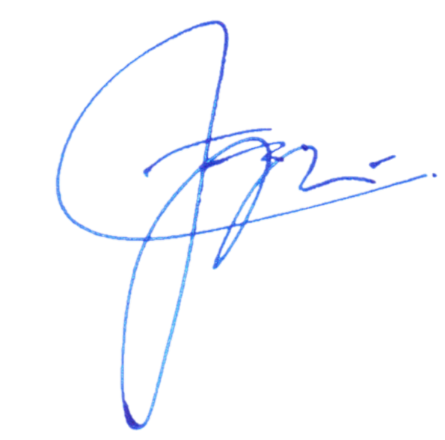
Bantul, 27 November 2020

(Farhah Kamilah)

