LAMPIRAN D2

MODEL SETELAH MODIFIKASI
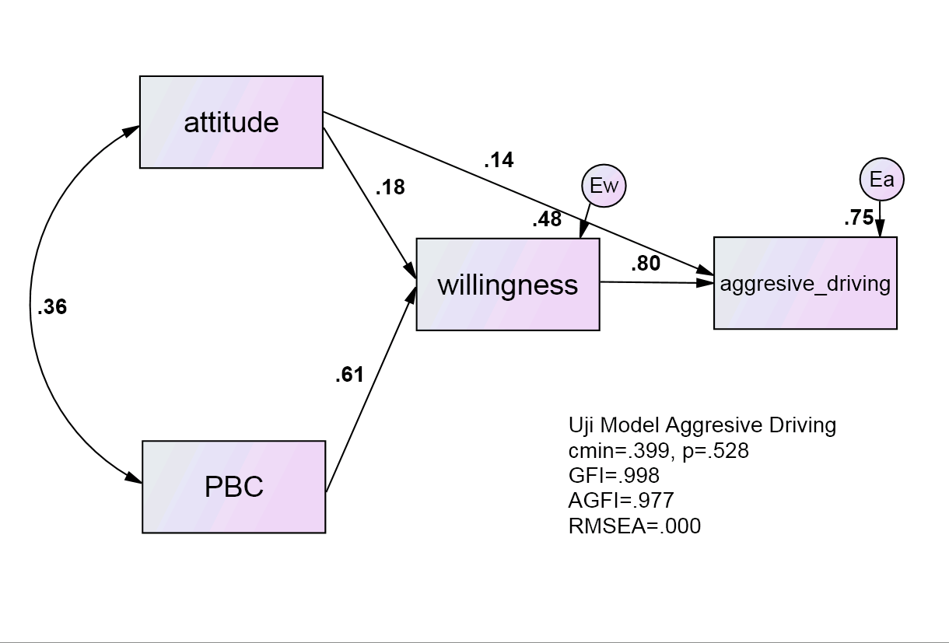

Models

Model Aggresive driving (Model Aggresive driving)

Notes for Model (Model Aggresive driving)

Computation of degrees of freedom (Model Aggresive driving)
Number of distinct sample moments: | 10
Number of distinct parameters to be estimated: | 9
Degrees of freedom (10 - 9): | 1

Result (Model Aggresive driving)
Minimum was achieved
Chi-square = .3988
Degrees of freedom = 1
Probability level = .5277

Group number 1 (Group number 1 - Model Aggresive driving)

Estimates (Group number 1 - Model Aggresive driving)

Scalar Estimates (Group number 1 - Model Aggresive driving)

Maximum Likelihood Estimates

Regression Weights: (Group number 1 - Model Aggresive driving)
 |  |  | Estimate | S.E. | C.R. | P | Label
willingness | <--- | PBC | .1638 | .0222 | 7.3748 | ***
willingness | <--- | attitude | .0692 | .0318 | 2.1761 | .0295
aggresive_driving | <--- | willingness | .6889 | .0499 | 13.7933 | ***
aggresive_driving | <--- | attitude | .0475 | .0193 | 2.4668 | .0136

Standardized Regression Weights: (Group number 1 - Model Aggresive driving)
 |  |  | Estimate
willingness | <--- | PBC | .6076
willingness | <--- | attitude | .1793
aggresive_driving | <--- | willingness | .7997
aggresive_driving | <--- | attitude | .1430

Covariances: (Group number 1 - Model Aggresive driving)
 |  |  | Estimate | S.E. | C.R. | P | Label
PBC | <--> | attitude | 460.0808 | 145.2712 | 3.1670 | .0015

Correlations: (Group number 1 - Model Aggresive driving)
 |  |  | Estimate
PBC | <--> | attitude | .3587

Variances: (Group number 1 - Model Aggresive driving)
 |  |  | Estimate | S.E. | C.R. | P | Label
PBC |  |  | 1835.1559 | 276.6602 | 6.6332 | ***
attitude |  |  | 896.6290 | 135.1719 | 6.6332 | ***
Ew |  |  | 69.4307 | 10.4671 | 6.6332 | ***
Ea |  |  | 24.6612 | 3.7178 | 6.6332 | ***

Squared Multiple Correlations: (Group number 1 - Model Aggresive driving)
 | Estimate
willingness | .4795
aggresive_driving | .7509

Matrices (Group number 1 - Model Aggresive driving)

Total Effects (Group number 1 - Model Aggresive driving)
 | attitude | PBC | willingness
willingness | .0692 | .1638 | .0000
aggresive_driving | .0952 | .1129 | .6889

Standardized Total Effects (Group number 1 - Model Aggresive driving)
 | attitude | PBC | willingness
willingness | .1793 | .6076 | .0000
aggresive_driving | .2864 | .4859 | .7997

Direct Effects (Group number 1 - Model Aggresive driving)
 | attitude | PBC | willingness
willingness | .0692 | .1638 | .0000
aggresive_driving | .0475 | .0000 | .6889

Standardized Direct Effects (Group number 1 - Model Aggresive driving)
 | attitude | PBC | willingness
willingness | .1793 | .6076 | .0000
aggresive_driving | .1430 | .0000 | .7997

Indirect Effects (Group number 1 - Model Aggresive driving)
 | attitude | PBC | willingness
willingness | .0000 | .0000 | .0000
aggresive_driving | .0476 | .1129 | .0000

Standardized Indirect Effects (Group number 1 - Model Aggresive driving)
 | attitude | PBC | willingness
willingness | .0000 | .0000 | .0000
aggresive_driving | .1434 | .4859 | .0000

Modification Indices (Group number 1 - Model Aggresive driving)

Covariances: (Group number 1 - Model Aggresive driving)
 |  |  | M.I. | Par Change

Variances: (Group number 1 - Model Aggresive driving)
 |  |  | M.I. | Par Change

Regression Weights: (Group number 1 - Model Aggresive driving)
 |  |  | M.I. | Par Change

Minimization History (Model Aggresive driving)
Iteration |  | Negative  eigenvalues | Condition # | Smallest  eigenvalue | Diameter | F | NTries | Ratio
0 | e | 1 |  | -.1778 | 9999.0000 | 155.1241 | 0 | 9999.0000
1 | e* | 0 | 31.5943 |  | 1.2727 | 14.4917 | 19 | .7645
2 | e | 0 | 31.2578 |  | .2703 | 1.9054 | 1 | .9291
3 | e | 0 | 25.0245 |  | .0687 | .4522 | 1 | 1.1115
4 | e | 0 | 23.3373 |  | .0145 | .3989 | 1 | 1.0303
5 | e | 0 | 23.7095 |  | .0008 | .3988 | 1 | 1.0016

Model Fit Summary

CMIN
Model | NPAR | CMIN | DF | P | CMIN/DF
Model Aggresive driving | 9 | .3988 | 1 | .5277 | .3988
Saturated model | 10 | .0000 | 0
Independence model | 4 | 192.2735 | 6 | .0000 | 32.0456

RMR, GFI
Model | RMR | GFI | AGFI | PGFI
Model Aggresive driving | 3.3196 | .9977 | .9774 | .0998
Saturated model | .0000 | 1.0000
Independence model | 206.7298 | .4998 | .1663 | .2999

Baseline Comparisons
Model | NFI  Delta1 | RFI  rho1 | IFI  Delta2 | TLI  rho2 | CFI
Model Aggresive driving | .9979 | .9876 | 1.0031 | 1.0194 | 1.0000
Saturated model | 1.0000 |  | 1.0000 |  | 1.0000
Independence model | .0000 | .0000 | .0000 | .0000 | .0000

Parsimony-Adjusted Measures
Model | PRATIO | PNFI | PCFI
Model Aggresive driving | .1667 | .1663 | .1667
Saturated model | .0000 | .0000 | .0000
Independence model | 1.0000 | .0000 | .0000

NCP
Model | NCP | LO 90 | HI 90
Model Aggresive driving | .0000 | .0000 | 5.0982
Saturated model | .0000 | .0000 | .0000
Independence model | 186.2735 | 144.6654 | 235.3042

FMIN
Model | FMIN | F0 | LO 90 | HI 90
Model Aggresive driving | .0045 | .0000 | .0000 | .0579
Saturated model | .0000 | .0000 | .0000 | .0000
Independence model | 2.1849 | 2.1167 | 1.6439 | 2.6739

RMSEA
Model | RMSEA | LO 90 | HI 90 | PCLOSE
Model Aggresive driving | .0000 | .0000 | .2407 | .5710
Independence model | .5940 | .5234 | .6676 | .0000

AIC
Model | AIC | BCC | BIC | CAIC
Model Aggresive driving | 18.3988 | 19.4831 | 40.7965 | 49.7965
Saturated model | 20.0000 | 21.2048 | 44.8864 | 54.8864
Independence model | 200.2735 | 200.7554 | 210.2280 | 214.2280

ECVI
Model | ECVI | LO 90 | HI 90 | MECVI
Model Aggresive driving | .2091 | .2159 | .2738 | .2214
Saturated model | .2273 | .2273 | .2273 | .2410
Independence model | 2.2758 | 1.8030 | 2.8330 | 2.2813

HOELTER
Model | HOELTER  .05 | HOELTER  .01
Model Aggresive driving | 848 | 1465
Independence model | 6 | 8

Execution time summary
Minimization: | .0160
Miscellaneous: | .3720
Bootstrap: | .0000
Total: | .3880

