Figure 1. Financial Flow.

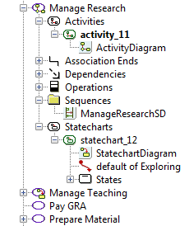
Figure 2. Design Methodology.
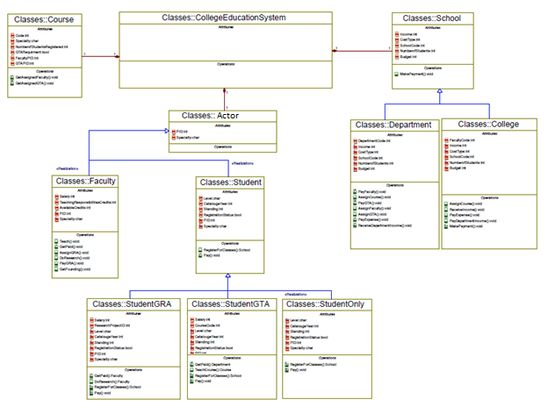Figure 3. Major Classes with Inheritance Relationship.
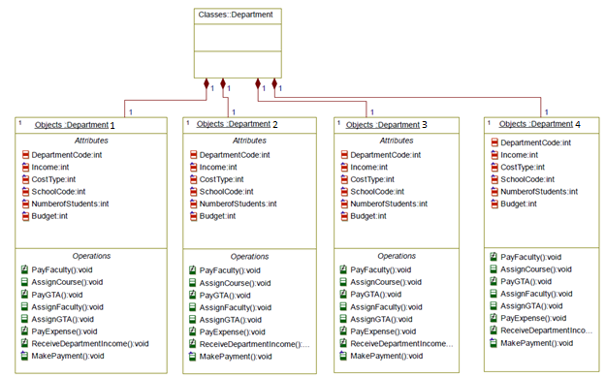Figure 4. Major Objects.
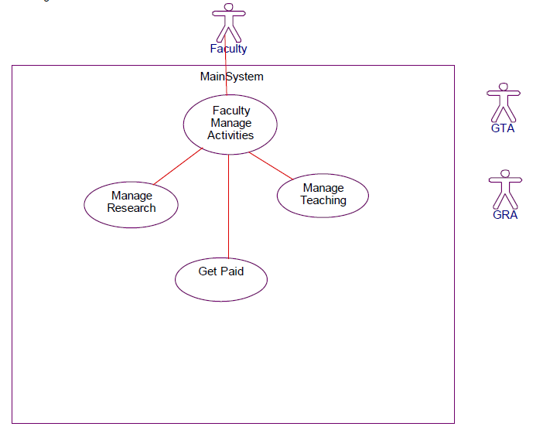
Figure 5. Main Use Case Diagrams of the Class Faculty.
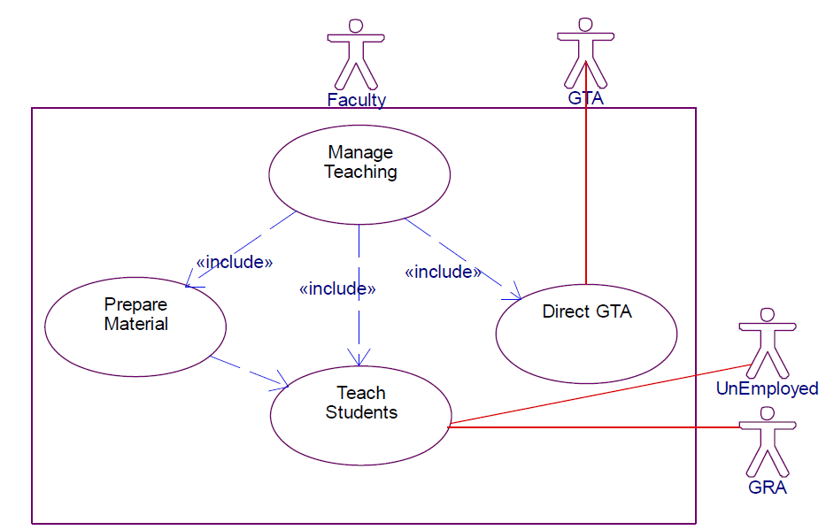
Figure 6. Use Case Diagrams of the Class Faculty - Manage Teaching.
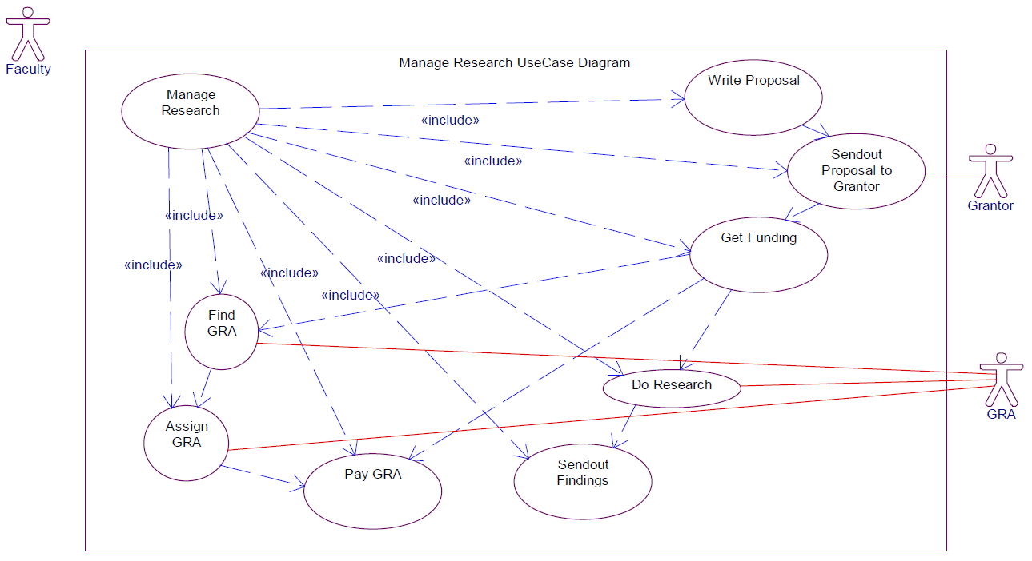
Figure 7. Use Case Diagrams of the Class Faculty - Manage Research.

Table 1. Simulation output
Course | Student (Double) | Student (Integer)
EM 5117 | 31.7 | 32
EM 5140 | 97.9 | 98
EM 5251 | 20.3 | 21
EM 5255 | 15 | 15
EM 5356 | 16.9 | 17
EM 6182 | 92 | 92
EM 6215 | 16.5 | 17
EM 6279C | 34.1 | 35
EM 6336 | 40.1 | 41
EM 6357 | 31.5 | 32
EM6645 | 6.9 | 7
EM 6649 | 7.4 | 8
EM 219 | 150.7 | 151
IE 5531 | 58.5 | 59
IE 6217 | 14 | 14
IE 6225 | 46 | 46
IE 6247 | 38 | 38
IE 6532 | 15.2 | 16
IS 6916 | 16.4 | 17
EM 5108 | 89.5 | 90
EM 6459 | 7.2 | 8
EM 6936 | 2.6 | 3
IE 6358 | 11 | 11
IE 6551 | 10.6 | 11
Table 2. Courses and Faculty Matrix
