LAMPIRAN GAMBAR DAN TABEL

1. GAMBAR

Gambar 2 QFM Down Grade

Gambar 3 QFM Reject/Scrap

Gambar 4 Diagram Fishbone Defect

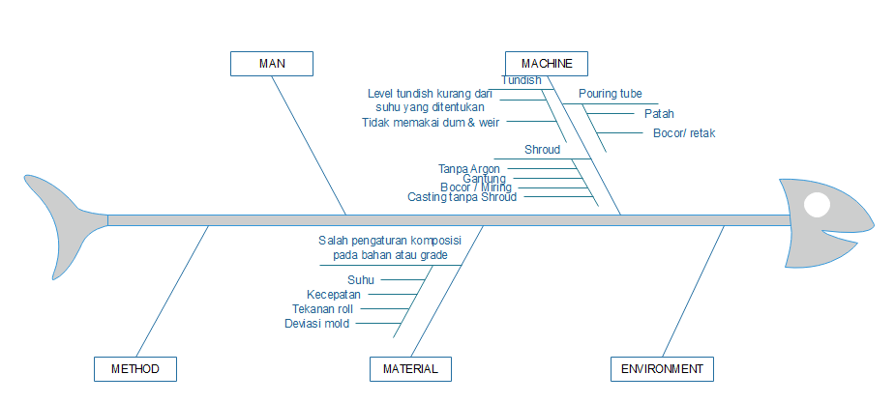

Gambar 5 Diagram Fishbone Over Production

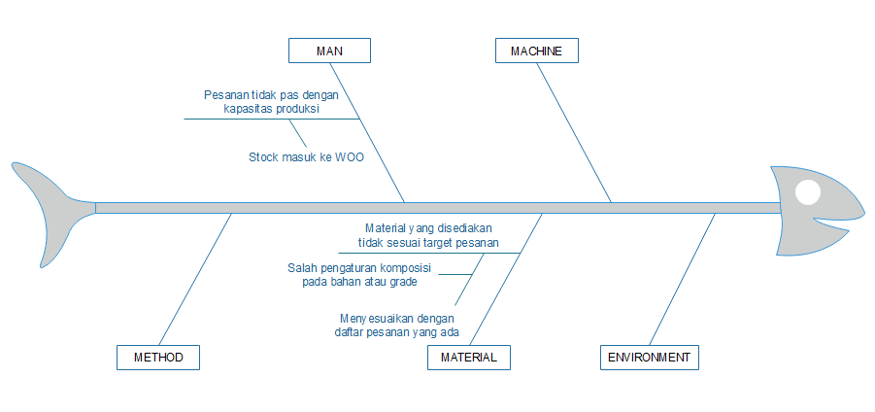

Gambar 6 Diagram Fishbone Waiting

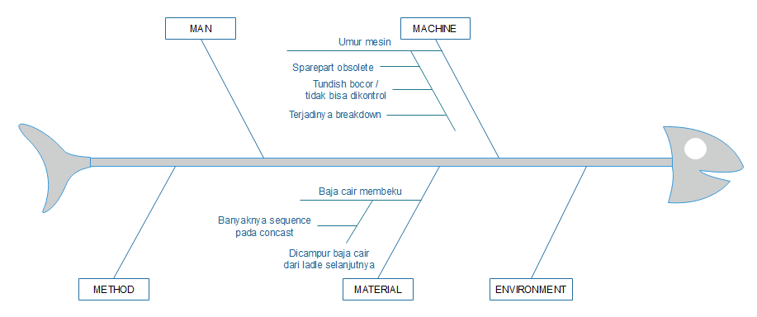

Gambar 7 Diagram Fishbone Unnecessary Motion

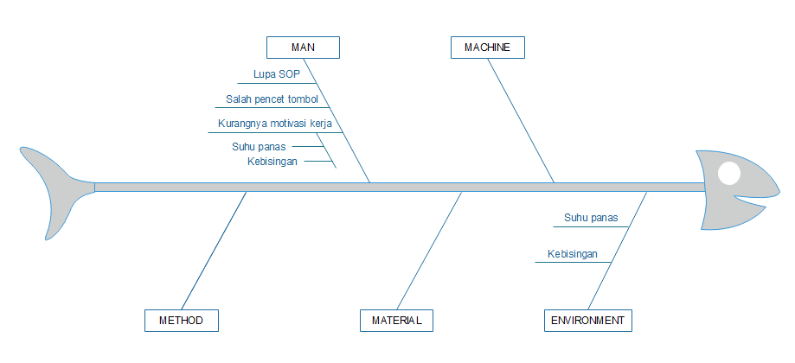

Gambar 1 Current Value Stream Mapping (CVSM)

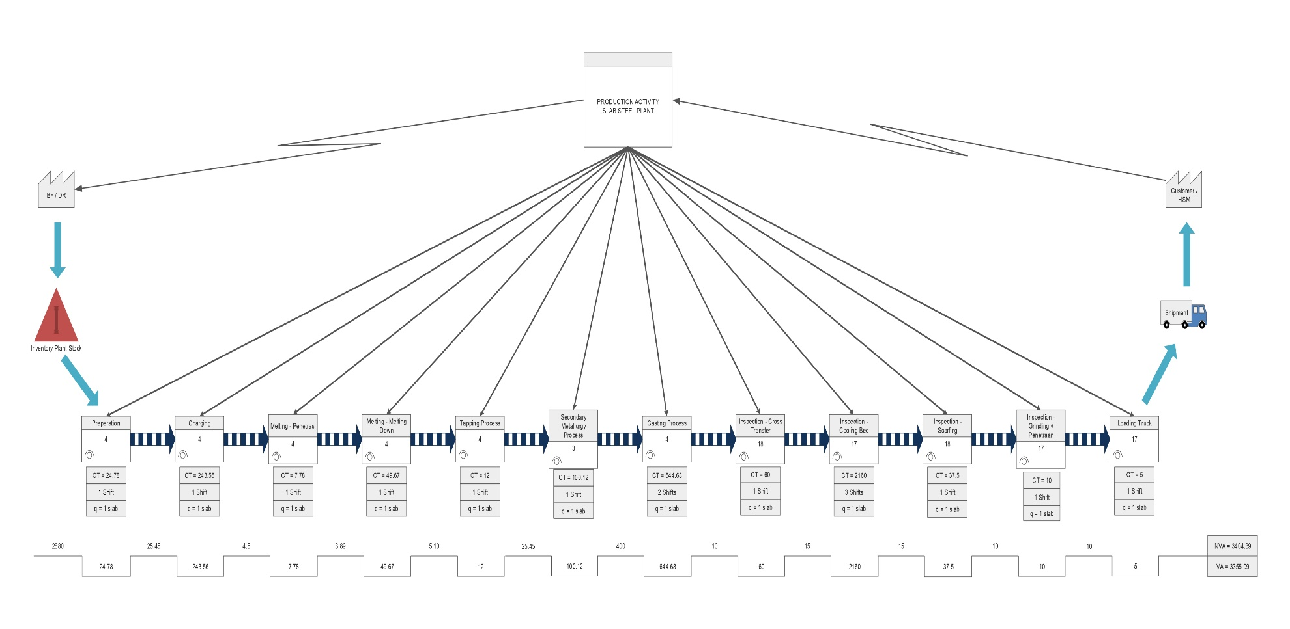

Gambar 8 Future Value Stream Mapping (FVSM)

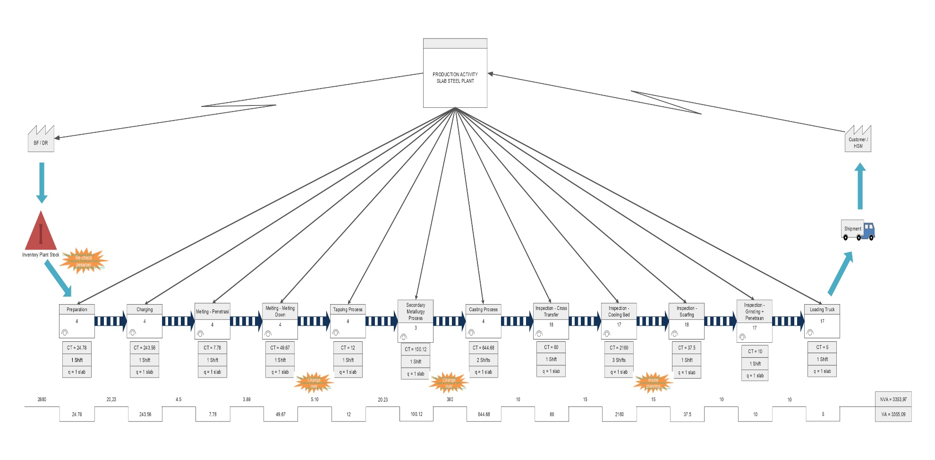

1. TABEL

Tabel 1 Perbandingan Biaya Kualitas



Tabel 2 Identifikasi 7 Pemborosan



Tabel 3 5W+1H



Tabel 5 Process Activity Mapping



Tabel 4 Hasil Pemilihan Tools VALSAT



Tabel 6 Penjelasan Process Activity Mapping



Tabel 7 Failure Mode and Effect Analysis

